Keep Calm and Learn On: Student Stress Management in a Fourth Grade Classroom
Susan Bohman

Introduction
When I first walked into a classroom as a new teacher twenty years ago, I faced many classroom management and student discipline challenges. I still remember feeling overwhelmed by the disruptive environment I encountered. Through the years I have tried a variety of methods to create the calm and peaceful classroom that I idealized in my mind at the beginning of my teaching career, and often times at the beginning of each new school year. Through my years of experience I have come to realize there will always be students in my classroom who need support and interventions to feel calm, focused, and ready to learn. Through my action research, I sought to evaluate if my use of interventions including mindfulness and stress reduction principles would bring about a calmer and more peaceful learning environment.
The Beginning of This School Year
The first weeks of school are a time for students to get familiar with classroom routines and reestablish friendships. Knowing that I was going to embark on action research to help my students monitor and manage their stress, I used these initial weeks of school to do some “kid watching.” I found moments in these first few weeks of school in which my fourth grade students seemed to struggle with routines and managing interpersonal relationships. Even during this “honeymoon period,” I observed students exhibiting negative behaviors such as being mad, sad, frustrated or angry. Below are some of the observations I recorded in my teacher journal:
- Jeremy came back from lunch upset. He engaged in many refusals and sat with his head on his desk. He seemed angry, and even angrier every time I calmly stated the classroom expectations to him. I calmly redirected until I had to ask him to take a timeout in the hallway so I could meet with him. He still seemed very angry. I asked him what was wrong or what happened. He said nothing. (9/14/16)

- I feel like the students need instruction on how to stay calm. Such minor things seem to “stress” them out. Julia gets stressed out just by having to take a notebook out of her desk and open it. Jeremy gets stressed out if he is redirected to follow classroom expectations. Anthony gets stressed out when he has to focus on the lesson. Some of them almost seem to intentionally create stress for themselves. If I ask them to use their supplies as tools they almost reflexively start playing with them. If I ask them to work “0” voice level so everyone can do their best thinking some of them start to make noise to themselves. It is as if their brain falsely interprets directions or reminders as stress. (9/16/16)

- In the morning Liam had a disrespectful attitude when he was asked to sit ready or take out materials. He would moan about it or slouch. He couldn’t seem to calm himself down or get himself back on track. (9/16/17)

- Vincent told me that Grant was playing “made you look” at lunch and it upset him. Joseph told me Julia was making faces at him when he was telling her he couldn’t concentrate. It is really time to start the social emotional learning. (9/20/16)

As I reflected on these observations, I was eager to see whether my action research would give me a framework to assist my students with social emotional issues that I continued to observe in my classroom year after year.
Question:
What happens when I teach students to monitor their wellbeing and feelings and give them strategies to de-stress and improve their mood?
Sub-questions:
- What happens to students’ disposition?
- What happens to students’ self-awareness?
- What happens to the strength of the classroom community?
- What happens to the vocabulary students’ use?
- What happens to students’ academic engagement and growth?

School Context
I teach at Talcott Fine Arts and Museum Academy (Talcott), which is a Pre-kindergarten through eighth grade level 1+ neighborhood public school, with two magnet cluster programs. Talcott is located in Chicago’s West Town neighborhood, which has experienced significant gentrification over the past decade. As a result, neighborhood streets that were once lined with moderately priced 3-flat apartments buildings have been replaced by large single-family million dollar homes. This has taken a toll on Talcott’s student population. The school once operated at full capacity enrollment of nearly 1,400 students, but currently has only 510 students.
Because of Talcott’s two magnet cluster programs, the school draws its student population from both the West Town neighborhood and city-wide. Talcott became a fine arts magnet cluster in 2007 and as a result, there is a fully staffed fine arts department that includes a dance, music, theater, and visual arts teacher. Talcott became a dual language magnet cluster in 2008. As a result, each grade level, Pre-K through 8, has one class in which the students are instructed in both Spanish and English with the goal of bi-literacy. Each grade level also has one general education (neighborhood) classroom in which the students receive instruction in English. All students, both from the general education (neighborhood) program and the dual program participate in the fine arts magnet cluster program. Furthermore, Talcott is Chicago’s first and only Museum School. Unique learning partnerships for children and families are established with the Art Institute, Field Museum, and National Museum for Mexican Fine Arts. Students routinely utilize Chicago’s museums to support learning.
According to our Chicago Public School (CPS) profile, Talcott is 83 percent Hispanic, 8 percent African-American, and 7 percent Caucasian. Additionally, 80 percent of Talcott’s students are classified as low income, 18 percent are diverse learners, and 39 percent have limited English proficiency. Daily student attendance has been measured at 96 percent for the past two years. Academically, 69 percent of Talcott’s grade 2-8 students are performing at or above grade level in math, and 67 percent are performing at or above grade level in reading.
My grade class consists of 19 boys and 8 girls for a total of 27 students. The diversity in the class is represented by 4 Caucasian students, 5 African-American students, and 18 Latino students. 80 percent of the students qualify for free or reduced lunch. Because of our school’s fine arts magnet cluster program, over half of my students do not live in the Talcott attendance boundaries and commute between 30-60 minutes to get to school. Parents make this commute because these students live in a neighborhood with a poor performing public school. 20 percent of my students are officially considered English learners (ELs), however, 50 percent speak Spanish some or all of the time outside of school.
Since there is only one general education class per grade, my students have been together since Kindergarten. There is about a 10 percent mobility rate and about two students leave the class and two new students join the class each year. Academically, based on NWEA national norms, 70 percent of the students are performing at or above grade level in math and 75 percent are performing at or above grade level in reading. As this is my thirteenth year teaching at Talcott, I have nine siblings of former students in my class this year.
Rationale and Literature Review:
Stress and anxiety are on the rise in children, classrooms, and schools.
When looking back on life, adults may regard elementary school as a “stress-free” time (Sotardi, 2016). However, over the years, I have seen students become more stressed out, moodier, and even angrier. As pointed out by many researchers, despite being one of the most popular topics in the social sciences, stress and coping have historically been overlooked in elementary schools (Sotardi, 2016). I have suspected that some of this increase in school related stress is due to the increasing academic demands and high stakes testing required by No Child Left Behind (NCLB), which is only increasing with the new Common Core State Standards (CCSS).
To my point, relatively little research has been conducted about the effects of high stakes testing on elementary school students due to federally mandated NCLB achievement assessments. However, a study by Segool, Carlson, Goforth, Von der Embse & Barterian (2013) reports significantly greater test anxiety on the high-stakes assessments compared to classroom tests. This finding indicates that high-stakes testing situations are more stressful and anxiety provoking for students. In the Chicago Public Schools, students in grades 3, 6, and 8 who do not achieve a certain score on the mandated high stakes test (currently NWEA), must attend summer school, and possibly repeat the grade. Once students experience this pressure in 3rd grade, it stays with them through the remaining years of school. For example, on beginning of the year surveys, I ask students to write a question they have about 4th grade, and students often ask if they have to “pass the test” to go to 5th grade. And, when I ask what they hope for in 4th grade, many students respond “to pass the test,” which seems sad when they could hope for a class pet, special projects or field trips.
Additionally, with the new CCSS, reading levels have accelerated by nearly two grade levels, and I am seeing fourth grade texts which were once considered at a fifth or sixth grade level. I have observed that with the CCSS, my students are working beyond their cognitive limits, thus increasing their stress level and negative feelings about learning.
Moreover, by understanding that students experience heightened feelings of stress and anxiety due to high stakes testing, as teachers, educators, and policy-makers we should more effectively prepare students to cope with these tests and additional academic demands. As pointed out by Segool et al. (2013), empowering teachers to use relaxation strategies prior to high stakes testing will benefit students who are expressing or exhibiting signs of negative thinking or feelings about evaluative situations.
Finally, stress can also trickle down from the district to the school’s administration to the teachers to the students. Because of this added stress and anxiety, schools need to explicitly address social emotional learning. Interestingly, teachers were also found to worry more about high-stakes tests than regular tests that are part of the classroom instruction. Research by Abrams, et al., has shown that when teachers experience increased anxiety and pressure, they alter instructional decisions to focus on high-stakes test preparation (as cited in Segool et al., 2013, p. 496). This teacher anxiety has also been found to indirectly influence the manifestation of student test anxiety.
Mindfulness and stress-management
I have incorporated social emotional learning activities over the past three years to address the increase in stress and anxiety that I have sensed my students may be feeling. I have mainly focused on the concept of mindfulness. In teaching students the practice of mindfulness, I have focused on the idea of mindful awareness, which is the skill of intentionally remembering to pay attention in the present moment (Black & Fernando, 2014). The goal of my previous mindfulness instruction was to coach students in skills that promote pro-social behavior in order to create a peaceful classroom. The primary tool that I have used to incorporate mindfulness practices is a curriculum called MindUP. The MindUP curriculum teaches students how the brain processes information, and how to use deep breathing to focus the mind to pay attention in the present moment. I have seen positive benefits from focusing on deep breathing when teaching mindfulness practices.
However, I have observed that my fourth grade students struggle with the mindfulness concept of “the present moment.” Mindfulness goes beyond stress management by covering ideas such as “mindful walking” and “mindful eating,” which are practices that encourage students to notice sensations and visualize. As I realized mindfulness lessons beyond deep breathing and paying attention in the present moment became less effective, I sensed I should focus my efforts on teaching students to manage the types of stress they encounter at school that Sotardi (2016) identified as (1) coping with learning challenges, in which students have a difficult time learning something new in class; (2) performance challenges, in which students receive an unsatisfactory grade on a test or report card; and (3) peer conflict, in which students felt another student had done or said something that bothered them. Black & Fernando (2014) highlight the similarities between mindfulness practices and stress reduction techniques, pointing out that lessons about mindfulness might be titled “mindful bodies and listening” and “mindfulness of breathing,” but would include stress reduction techniques such as sitting in a relaxed posture or concentrating attention on the sound of a chime from start to finish.
Therefore, I want to continue to incorporate what has been an effective practice, deep breathing, but use language that is more friendly to fourth graders, like stress, feelings, and emotions, and focusing on concepts like stress management, rather than mindfulness per se. By doing so, the topic will hopefully be more concrete and relatable to fourth grade students, and more stress management techniques can be incorporated.
Learning stress management in the intermediate grades may help students face future challenges.
It has been established that teaching social emotional skills such as the ability to manage stress and emotions play an important role in both academic and life success (Romano, Miller, & Nordness, 1996). Stress will only increase for my fourth grade students as they get older. When my students are in sixth and eighth grade they will once again have to meet a cut score as part of the district’s promotion policy. When my fourth grade students are in the seventh grade they will be under tremendous pressure to get all A's and high test scores in order to be admitted to a good high school. In eighth grade they will face the pressure of taking an admissions test to get into selective enrollment high schools. When my students enter adolescence they may have to make difficult decisions in the face of peer pressure.
Caprara et al. (2002) found that social and emotional competence in grade three was a better predictor than academic competence of academic achievement in grade eight (as cited in MindUP 2013). Teaching my fourth grade students stress management techniques will hopefully benefit them when facing these stressful situations that may arise in the future. Romano, Miller, and Nordness reason that student well-being curriculums are important in elementary guidance programs because students are at risk for problematic behaviors in the future and they further found that well-being curriculums should be taught in phases and reinforced throughout elementary years (1996).
Learning how to deal with stress at school will hopefully help students deal with stress outside of school. It seems like some students are stressed and angry before school even begins. As teachers, we may sense, but not actually know the level stress students have in their home lives. Sotardi (2016) also concluded that teaching coping skills to students in early grades is important because without effective coping strategies students may stop trying to improve undesirable conditions in their lives.
Monitoring and managing stress and emotions is related to positive learning outcomes.
The happier and less stressed students are, the better they learn. The brain’s response to stress is linked to a clump of nerves deep in the center of our brains in an area called the amygdala (MindUP, 2013). The amygdala serves as an “information filter” regulated by our emotional state, and is important to learning because when students are relaxed, the “information filter” is wide open and information flows to the prefrontal cortex for executive processing. This reminds me of Stephen Krashen’s (1982) affective filter theory that I learned when I was studying for my ESL endorsement. The affective filter theory asserts that lowering anxiety makes students better equipped for second language acquisition.
I have found this hypothesis to be true for all learning. Students should associate school and the classroom with positive feelings because it increases the chance students will become lifelong learners, and it increases their positive disposition to learning. By creating an opportunity for students to monitor and manage their stress, I am creating a more positive learning environment. When students feel stress and anxiety, executive functions, which provide cognitive control, are inhibited. Therefore, information doesn’t flow into the prefrontal cortex for executive processing. Because of this, stress and anxiety shut down higher order thinking (MindUP, 2013).
The benefits of checking in with students through a stress and well-being journal.
In a recently published longitudinal study by Sotardi (2016) that examined daily stress and coping strategies of elementary school students in the United States in grades three through five, the researchers had students maintain a daily journal for eight weeks, in which each day students filled out a Stress-O-Meter. The Stress-O-Meter allowed students to self-report their perceived stress at school on a 5-item Likert-style scale (smiling to frowning faces). My idea to have students keep a stress journal with a stressometer is similar to the method used in Sotardi’s (2016) data collection. However, rather than a 5 item-Likert-style scale, my students reported their perceived stress on a visual representation of an actual meter with a 10 point scale. Further, my students co-created the language used on the 10-point scale to rate their level of stress and wellbeing. Rather than keeping the journal daily, my students filled out their stressometer three times a week during our class meeting time, or at times students tended to feel more stress and anxiety, such as before a test or after an incident at recess. While there was no place on Sotardi’s (2016) Stress-O-Meter for written reflection, the researcher did interview students about their responses. In the stress and well-being journal that my students completed, there was a space for written reflection under their self-reported rating. My students also completed a written reflection on what stress management techniques have helped them de-stress in their journal. As in Sotardi’s (2016) study, I interviewed students individually and in small groups throughout the data collection.
Implementation & Data Interpretation
Data collection methods
Field Notes Lessons in which I taught students to monitor their wellbeing, feelings and manage their stress took place during our classroom meeting time. I used a SmartBoard throughout lessons to present to the student the prompt or question under discussion, and then the students’ responses. The notes were kept in a Google document and saved on the Google drive. Through these field notes I captured how the students responded to the lessons, to each other, and how responses changed over time, and thus how their ability to manage their stress and emotions also changed over time.
Student Stress Meter Drafts: The students worked in groups to create meters that could be used by the entire class to manage and monitor stress.
Student Keep Calm and Learn On Journal (Stress Journal): Students kept a journal in which they used a visual aid (meter) to monitor their stress and mood. After rating themselves, students gave a written rationale for their rating, as well as strategies used to de-stress and improve their mood.
Student Surveys: Students completed a survey in which they recorded their total hours of sleep each night. Students charted their activities in the hour before their bedtime. After the initial survey, students kept a sleep journal for two weeks. After the first week, the journal was reformatted based on feedback from the students.
Teacher Journal: Throughout the research process I kept a journal in which I recorded observations, thoughts, and events surrounding my students’ progress in monitoring and managing stress.
Implementation & Data Interpretation

Stress from the Students’ Perspective
Defining Stress: The process of encouraging my students to monitor and manage their stress began in September during our regular class meetings. During one of our initial meetings, the students recorded sources of stress in their life. The students then turned to a partner and shared what they wrote in their journals, and then compared and contrasted their responses. Finally, the students had a chance to share their thinking during a whole class discussion. The discussion around this question generated the following responses grouped into categories:
Emotions
- Feel mad, sad, upset, confused, frustrated
Cognition
- Hard time thinking
- Feel pressured
- Hard time making decisions
- A lot on your mind
Physical Symptoms
- Head hurts
- Stomach hurts
- Heart races
- Start sweating

Following the same discussion format, the students described causes of stress, grouped by context:
Home
- Brother calls me names
- Choice of only one thing
- When you want something and your parents won’t buy
- Sister yells at me or talks too much
- Hosting a party
- When you feel jealous that your brother or sister has something you don’t

School
- Get in trouble
- When you don’t understand something at school
- Math
- Taking a test and you don’t know the answer
- A lot of homework
Not Location Specific
- Get in trouble
- Sports game and team not working together/listening
- When people change the rules in games
- Too many people telling me to do things
- Sharing
- When you don’t want do something you are told to do
- Getting injured

The students’ responses indicate that they experience stress both at school and outside of the school setting. When students gave their initial thoughts on stress, they associated with feeling upset, confused or frustrated. When analyzing their responses to what causes them stress, each example does illustrate a situation in which a student may feel upset, confused or frustrated. In defining stress, students also listed the physical symptoms of stress such as sweating, a racing heart, stomachaches, and headaches. Given that my students are 9-10 years old and experiencing stress and physical symptoms of stress, I felt it would be useful to continue using class meeting time to check in with students about their feelings related to stress and give them strategies to manage their stress to hopefully address the unpleasant physical affects of stress.
The students’ description of stress led me to look up the actual definition in the dictionary and compare it to my students’ definition.
Merriam-Webster Kids Dictionary definition of stress:
a physical, chemical, or emotional factor that causes bodily or mental tension and may be a factor in disease causation; a state resulting from a stress; especially : one of bodily or mental tension resulting from factors that tend to alter an existent equilibrium.

In comparing my students’ definition to the Merriam-Webster definition, my students gave concrete examples of physical and emotional factors that lead to stress. Further, my students also listed concrete examples of how stress made them feel. Based on these initial discussions about stress, my students were able to recognize feelings of stress, and I felt my fourth grade students were developmentally ready to learn strategies to monitor and manage their stress. Further, at the end of the discussion my students indicated a desire to keep learning about stress and how to manage it.
Creating a Tool to Monitor Stress: During subsequent class meetings the students worked in small groups to design a tool to monitor their stress levels. As a result of a class discussion, the students agreed that the tool to monitor their stress levels should resemble a meter. Each group created and presented a possible meter that could be used as a tool to monitor their stress levels. The following are examples that highlight two different approaches groups took to completing the meter:
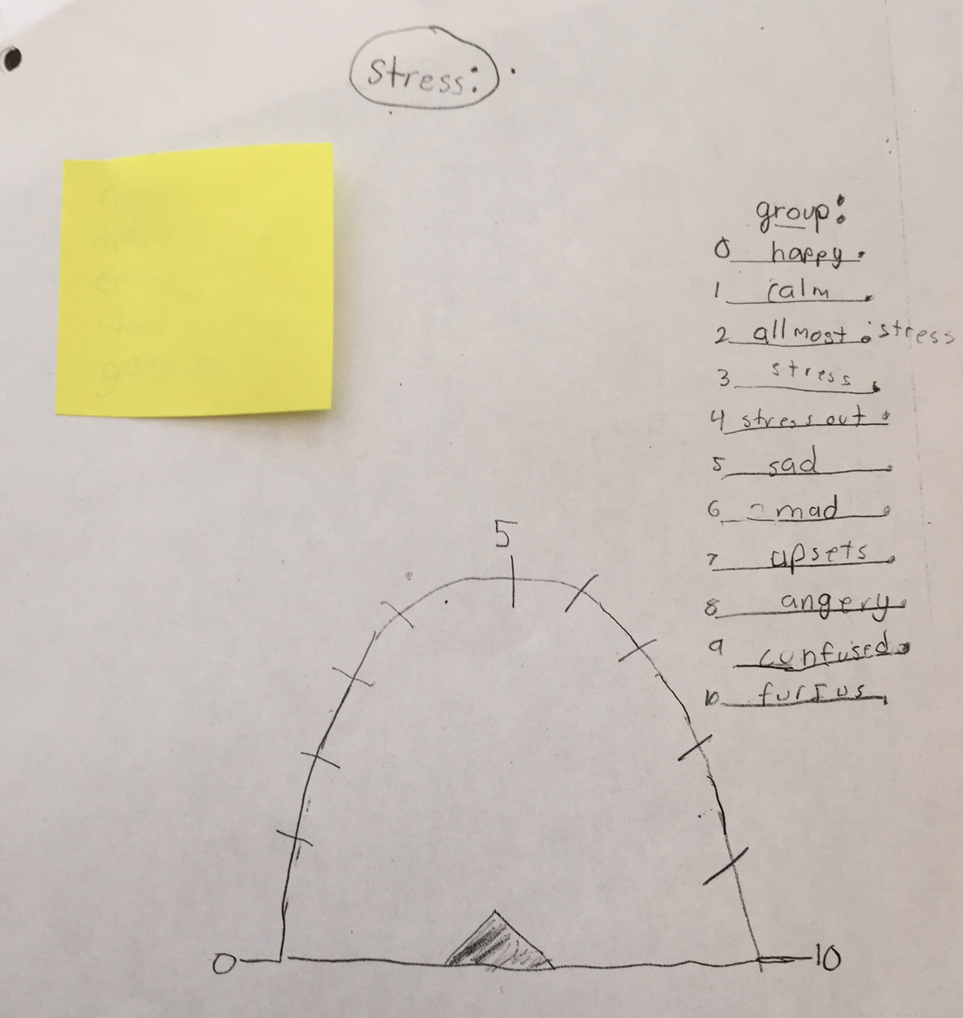 | 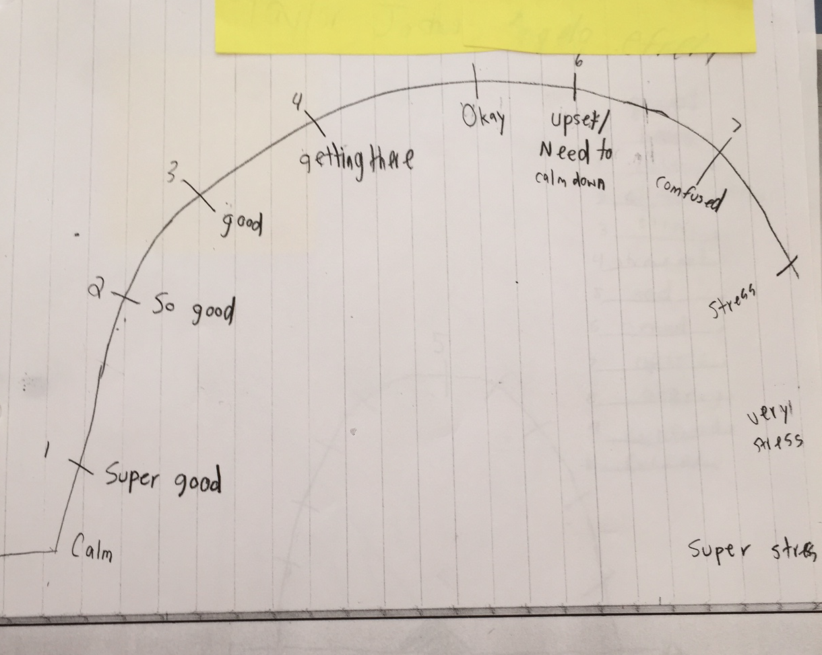

The stress ratings on the above meters are as follows:

0 = happy  1 = calm  2 = almost stressed  3 = stress  4 = stressed out  5 = sad  6 = mad  7 = upset  8 = angry  9 = confused  10 = furious | 0 = calm  1 = super good  2 = so good  3 = good  4 = getting there  5 = okay  6 = upset/need to calm down  7 = confused  8 = stress  9 = very stressed  10 = super stressed

These charts show the intuitive understanding my students had between stress and feelings. For instance, feeling calm was correlated with the emotion of happiness, and feeling stressed was correlated with feelings of being angry, confused, and furious. The language used by the students
reminded me of my journal entries from the early weeks of school when students like Jeremy, Julia, Anthony exhibited anger and frustration and needed to calm down, and it felt rewarding to realize I was creating a tool to help my students share and manage these feelings.
Initial Results: After selecting the meter design, the students decided to name it a stressometer, comparing it to a car’s speedometer. Each student created a hand-drawn stressometer on an index card and gave themselves a rating and wrote a reflection to see if the meter concept would be a useful tool to reflect on their well being and feelings related to stress. Below is a table of responses from the initial stressometer. 1 is calm, 5 is getting stress, and 10 is completely stressed (a picture of the original meter is in the appendix):

Name | Rating | Reason
Vincent | 4 | At recess, I never had the ball and everybody jumped on me, but I never had the ball.
Sydney | 5 | I have been friendly and helpful, but some people have not.
Charles | 10 | When I got a F on my paper and I hate my mom.
Douglas | 6 | I had fun but got hurt at recess.
Carrie | 3 | I had to hurry to get in line because I had to put my food away.
Alexi | 3 | I’m kinda mad because they canceled band.
Matthew | 7 | Because my mom is going to Mexico for 2 weeks and my grandma is really sick.
Andrea | 4 | I started getting dressed this morning when I was already running late and I wanted to be early to school.
Omar | 3 | When I played football (at recess) I got wet.
Joseph | 5 | All the book order forms are gone and I didn’t get one.
Robert | 10 | I’m not happy because I didn’t get sleep.

About fifty percent of the students who completed the meter reported feeling some level of stress. The most prevalent reason given was recess, but there were also reasons related to issues at home, such as Charles expressing frustration with his mom. Upon reflection, I connected certain student behaviors I had seen in the classroom with their stressometer reflections. For Robert and Charles, who reported stress levels of 10, I had seen outward signs of stress exhibited during the school day. Robert was sitting with his head on hands or arms all day looking visibly miserable, and Charles was distracted during the lessons and looking down like he was lost in his thoughts. These initial meter responses reminded me that there is often so much more than meets the eye when observing students’ behavior.
Based on this initial data I felt it would be beneficial to continue to formalize the process of checking in with students about their feelings related to stress. Further, the students’ written reflection allowed them to go into more detail about why they were feeling stress at school or at home, and thus was a key tool for me to use in responding to my students as they learned to manage their feelings of stress.
Monitoring and managing stress: Checking in with students and responding to their needs
Using Stress Journals to Respond to Individual Student Needs
After designing an “official” stressometer, I created a journal called “Keep Calm and Learn On” to check in with students three times per week. I placed the journals on the students’ desks while they were at their 45-minute recess and lunch period. Upon returning from the recess and lunch, students would spend about 10 minutes filling out a stressometer and writing a reflection. On the stressometer, the students rated their stress level from 1-10, with 1 being calm and 10 being stressed (see Appendix for a copy of the journal page with the stressometer). There was also a place in the journal where students indicated what strategies they had been using to de-stress. I collected the journals each day after the students were finished. At the end of each week students completed an additional reflection.
Each day, after I collected the journals, I reviewed them and looked for individual students who indicated they were feeling stress. Based on the written reflections from the journals, I conferenced one-on-one with individual students who said they were feeling a high level of stress. I was able to complete these conferences on the same day the journal entry was completed. Below are examples of journal entries that led to conferences and the outcome:

Name | Rating | Reflection | Conference/Outcome
Charles | 8 | My mom always yells at me at my face and always mess up my day. | Talked with Charles about everything moms have to do. Asked him to put himself in his mom’s shoes so he could appreciate all she does. A few weeks later he wrote an essay titled, “My Mom is Special.”
Grant | 5 | Sometimes you have to do homework but you don’t want to do it but you have to do it. | Framed homework positively with Grant. Related to playing a sport and how homework is like practice. He talked about how he plays baseball and how he tries really hard at practice.
Dale | 8 | I’m frustrated because I want to change my book group because my book group keeps giving me a hard time. | Met with Dale’s book group and went over bookmark that outlined the routine for book club and the norms the book group created. They were able to get through the novel and then I switched Dale to a new group where he was more productive.
Robert | 10 | Dale is saying I have lice. | I suggested Robert give Dale space and find a friend he could count on not to call him names. For several weeks I checked in with Robert to see if Dale was still calling him names. I also checked in with Robert to make sure he had found a friend to play with at recess.

By using student-reported data from the stress journals, I was able to respond directly to causes of stress and create better social and learning conditions for students. Peer-to-peer relationships improved because students would alert me to issues of concern such as Dale’s book club, and I was able to intervene and keep the group working productively. I also used positive framing to put stressful situations in a new light for my students, such as Charles’s complaints about his mom, or Grant’s complaints about homework. Using positive framing to help students see other perspectives had a positive effect on my one-on-one relationships with these students. I was also able to provide new students to the classroom, like Robert, an outlet for their experiences and tools for a successful transition.
Examining Root Causes of Stress
The students kept the “Keep Calm and Learn On” journals for a four week period beginning on January 9, 2017, the day the students returned from winter break. After the first four-week period the students then gave feedback about the journal format during a class meeting. Changes were made to the journal format based on that input. The students then completed a second four-week cycle starting on February 6, 2017. In the second cycle, based on student voting, the students went from using an open-ended question about the causes of stress to selecting from a menu of choices about the causes of stress (including a choice of “other,” see appendix for the cycle one and cycle two stress journal pages).
As a result of the two cycles of journaling, I was also able to get an overall picture of the factors that cause my students stress, and changes in the overall picture from the first cycle (1/9/17-2/1/17) to the second cycle (2/6/17-3/3/17) based on classroom level interventions.

Table 1: Matrix of Stress Factor Contribution by Stress Intensity
First Cycle of journaling = 1/9/17- 2/1/17
Second Cycle of journaling = 2/6/17- 3/3/17
 | Level  0-2  “calm” |  | Level  3-5  “getting stressed” |  | Level  6-8  “stressed” |  | Level  9-10  “Very stressed”
Stress Factors | First Cycle | Second Cycle | First Cycle | Second Cycle | First Cycle | Second Cycle | First Cycle | Second Cycle
Lunch/recess | 6.7% | 37.0% | 19.6% | 7.7% | 18.2% | 11.1% | 23.5% | 50.0%
Sick/tired | 0.0% | 10.9% | 43.5% | 38.5% | 31.8% | 66.7% | 41.2% | 33.3%
Academics | 19.6% | 6.5% | 8.7% | 7.7% | 0.0% | 0.0% | 23.5% | 0.0%
Home | 2.8% | 15.2% | 21.7% | 15.4% | 27.3% | 11.1% | 11.8% | 8.3%
Friendships/ peer conflicts | 8.9% | 10.9% | 4.3% | 15.4% | 22.7% | 11.1% | 0.0% | 8.3%
Other | 62.0% | 19.6% | 2.2% | 15.4% | 0.0% | 0.0% | 0.0% | 0.0%

One piece of the data that stood out to me was the “other” response. I observed that switching from open-ended responses during the first cycle to a menu of choices during the second cycle, the “other” response went down from 62% to 19.6% when students indicated a feeling of calm. During the first cycle of journaling the “other” responses were most commonly explained by students as, “I feel happy” or “I feel calm,” without a specific reason given. In the second cycle of journaling, however, lunch/recess as a cause of feeling calm increased from 6.7% during the first cycle to 37% during the second cycle. This may indicate that during the first cycle “other” responses related to feeling calm were often connected to how students were feeling after lunch/recess. While on the subject of lunch and recess, it was the leading cause of stress during the second cycle of journaling. Lunch and recess seems to be the pivotal point in the day in which students experience positive or negative feelings. This data reminds me how important it is for me to be proactive in managing student interactions that happen outside of the classroom during lunch and recess. The “other” response also stood out for level 9-10 “very stressed” responses. If students indicated feeling a 9-10 level of stress, they never indicated “other” as the reason. When feeling this level of stress students could give a specific reason, which allowed me to follow up with a one on one conference to address their concerns or feelings.
Both cycles of journaling illustrate how the reflection under the meter was more important than the rating on the meter itself. For example, Carrie on 2/6/17 rated herself a “0” on the stressometer because, “At first I didn’t understand the math but then she explained it so I understood it.” Conversely, on 2/6/17, Vincent rated his stress level at “7” because “Someone was getting off focus in math and I didn’t understand.” Carrie’s response shows me she persevered even though she was at first confused and she takes ownership over her learning. On the other hand, Vincent’s response shows me he didn’t take ownership over his learning and let himself get distracted by another student, something I had seen in the past. Because of the written responses in the journal I was able to reinforce Carrie’s “stick-to-it-ness” and I was able to give Vincent a note taking strategy to help him stay engaged more on the lesson and less on other students in the class. These examples illustrate my finding that it was not the ratings on the meter, but the written reflection that gave me the opportunity to be more responsive to my students.
Strengthening Students’ Ability to Manage Stress
Through the “Keep Calm and Learn On” journals I also monitored what strategies students use to calm themselves when feeling stressed. Below are the results from the two cycles of journaling:

Table 2: Use of Stress Reduction Techniques by Percentage
First Cycle of journaling = 1/9/17- 2/1/17
Second Cycle of journaling = 2/6/17- 3/3/17
Technique | 1st cycle: % of students | 2nd cycle: % of students
Breathing | 42.4% | 37.9%
Mantra | 23.7% | 37.9%
Read | 0.0% | 17.9%
Tell Adult | 1.7% | 4.2%
Talk to someone | 5.1% | 8.4%
Draw | 6.8% | 8.4%
Stress ball | 0.0% | 11.6%
Other | 20.3% | 1.1%

Strategies to stay calm were modeled and practiced during class meetings. During the first cycle, as a class, the students focused on practicing deep breathing, and this was the most commonly used strategy during both cycles, while using mantras was the second most common strategy. The mantras had a personal touch because they were created during our class meetings to respond to what I was reading in the journals. For academics, the students agreed on mantras such as “Just try my best” or for recess students decided to tell themselves “Just stay calm” when feeling stress.
One piece of the data that I felt was misleading related to the strategy of “Telling an adult” as a way to de-stress. This strategy was listed as the third most frequently used strategy, however, upon reflection, I realize that just keeping the stress journal was an opportunity for students to tell the teacher how they were feeling or what was causing them to feel stressed on a regular basis. If the student reported feeling a higher level of stress, I would follow up with them one-on-one. If this connection between journaling and “telling and adult” had been made more explicit, this may have been a higher rated strategy. Overall, I feel giving the students this opportunity to “tell an adult” through the journal allowed me to be more responsive to my students negative feelings, and had the greatest impact on reducing my students’ stress.
Again, the “other” response stood out for stress reduction strategies as well. Because “other” was listed 20 percent of the time during the first cycle, a menu of choices was used during the second cycle (see Appendix). Students listing “Other” went down to 6 percent during the second cycle, most likely because students had a menu of choices, rather than an open response. The menu was important because it reminded students how to manage feelings of stress. Thus, regularly showing students specific strategies may serve as a reminder to use them.
As I reflected on these journal entries, it struck me that there is no one set of experiences that leads to stress in my students. Rather, all students experience unique circumstances in their academic and social lives that cause them worry or concern. I cannot remove these sources of stress since they are the day-to-day experiences of my students as they interact with classmates, teachers, friends, and family members, but the key is to listen to their concerns and give them support and techniques to strengthen their ability to manage feeling of stress.
An Ounce of Prevention is a Pound of Cure: Preventing Stress By Focusing on Wellness

During a class meeting in early February, after completing our “Keep Calm and Learn on Journals” for four weeks, the students responded to the question, “In looking over your journal, what comes up the most when you are feeling stress?” The question was initially answered using a strategy called “go around” in which each student shares one response. While the students were responding, I was inputting the answers and tallying them on the SmartBoard. One of the most frequent responses (40%) was feeling exhausted or sick. This class meeting was a proverbial “light bulb moment” that inspired me to shift my focus from not only managing stress, but also to preventing it.
Two days later, at our next class meeting, the students read a Newsela article titled, “How do mice learn and remember? They need deep sleep?” After reading and discussing the article, I had the students reflect on how much sleep they were getting each night by listing the time they go to bed, the time they wake up, and what they do in the hour before bed, in what would be the first of three weekly sleep surveys. The results for the weekly sleep surveys are as follows:
Sleep Survey Results
Hours of Sleep | 7-7.5 hrs./night | 8-8.5 hrs./night | 9-9.5 hrs./night | 10-12 hrs./night
Initial Survey: % of Students | 13% | 30% | 35% | 22%
Week 2: % of Students | 5% | 11% | 21% | 63%
Week 3: % of Students | 0% | 5% | 32% | 63%

According to pediatricians, the optimal amount of sleep for a 9-10 year old is 10-11 hours per night. When students consistently do not get enough sleep it can also cause a cumulative effect known as sleep deprivation. As the initial survey shows, 13 percent of the students were consistently getting 2-3 hours less sleep a night than needed. These students, like Robert, Dale, Orlando, Vincent and Jeremy, are easy to spot in the classroom. They have their head in their hand, they doze off, are easily distracted by other students, or they play with objects to keep themselves over-stimulated so they don’t fall asleep.
On 2/9/17, just one day after students read the article and completed the initial survey, I heard some interesting and relevant comments related to the Newsela article on sleep. I noted in my journal, “When I greeted the class in the morning Andrea told me, ‘I got REM sleep last night.’ Ali and some of the boys agreed.” That same day a group of the band students went to a concert. Again, I noted in my journal, “When Dale returned from the band concert he said he was so tired ‘because he didn’t get enough REM sleep.’ ” The article about REM sleep immediately made its way into the students’ daily vocabulary. It seemed as if a light bulb went off and students saw a connection between sleep and feeling calm, focused, and ready to learn.
The Monday (2/13/17) after the initial survey I showed students short videos on the connection between sleep and memory/learning to reinforce and further the previous discussion. At the end of the discussion I introduced the idea of keeping a weekly sleep journal to the students. The students then created and kept a sleep journal for one week (see Appendix for examples of the weekly sleep journals).
After one week the number of students getting the optimal amount of sleep, 10-12 hours, increased by 40 percent. One student who improved immediately during the implementation of the sleep plan was Robert. Going back to the very first stressometer that Robert completed back in December he said his stress level was “10” because “I am not happy because I did not get enough sleep.” During week 1 of the sleep intervention, Robert increased his sleep from seven to 10-11 hours per night. The change in his body language and attitude toward learning were quickly recognizable. During this week, I noted in my journal on Thursday 2/16, “Robert is like a new person. He has not put his head down or closed his eyes. I also notice he is not involved in as many interpersonal conflicts.” Other students also noted the effects of getting more sleep in their journal. In Nicolas’ stress journal he wrote (2/16), “I slept good last night and got 10 hours of sleep,” as the reason he felt calm. Another student rated his stress level a “0” and wrote, “Not tired at all.”
I also initially surveyed students about their activities in the hour before they go to sleep, and over 75 percent listed screen time, which included playing on a tablet, Smartphone, computer, or watching television. I then reviewed student responses in the sleep journal as to their activities one hour prior to bedtime. Now, only 10 percent listed screen time. This is a significant reduction, given that in the initial survey 75 percent listed screen time as a before bed activity. Not only is reducing screen time important to getting a restful sleep, but in place of screen time students reported that they were engaging in more reading, playing with toys and pets, and playing games with family members.
The survey was adjusted after the first week to include a menu of choices for students to select from when indicating the activities they completed in the hour before sleep and techniques they used to fall asleep. Like the stress journals, the students voted on the menu choices, rather than open-ended responses. After two weeks of focusing on the importance of sleep, no students reported sleeping only 7-7.5 hours per night, and 63 percent of the students continued to get the optimal amount of sleep, while another 32 percent were close to getting the optimal amount of sleep. Again, the reduction in screen time the second week was similar to week one in which 10 percent of the students listed screen time as a before bed activity.
One student who stood out in the second week of the survey was Jeremy. Jeremy resisted changing his sleep habits during the first week of the study. Jeremy is a student who would fall asleep or look like he was about to fall asleep nearly every day. After seeing that Jeremy did not embrace the idea of following a sleep plan during week 1, I reached out to his parents. As a result he kept a sleep plan during week 2, and like Robert, the results were immediately recognizable as he was sitting up during lessons and completing more classwork. During the course of the second week Jeremy approached me and said, “Four days.” When I gave him a puzzled look he explained to me that it had been four days since he had fallen asleep in class. Jeremy’s grades also improved. The following week, during our weekly grade check he informed me he didn’t have any more Ds.
The change in vocabulary as a result of focusing on the importance of sleep persisted. In mid March, during science I couldn’t remember where I put the balloons for an investigation and a student said, “I think you need more REM sleep.” At the end of April the students took a test over figurative language, and when I collected Dale’s test and told him it looked like he did a great job, he told me, “I got 12 hours of sleep last night.”
Unfortunately, during both weeks of the sleep survey seven students did not return their surveys, even after I provided parents with the survey by e-mail. I need to continue to reflect on ways I can strengthen the school-home connection to promote wellness.
The incorporation of the concept of prevention and wellness was a critical step in my students being able to successfully use stress management techniques in the classroom and in their interpersonal relationships. Once my students were educated on the value of sleep and were able to chart their sleep time, they quickly drew the connection between preparing for and getting adequate sleep and improved concentration and results in the classroom. The reduction in screen time before bed not only helped them get a good night’s sleep, but led them to engage in healthier activities with their families instead. I began this process by giving them the information, but I think the way the students “ran with it” was connected to the overall process of taking control of their feelings and emotions through the stress reduction techniques already in use in the classroom. Going forward, I am eager to discuss wellness from the outset of the school year as I hone this process.
High Stakes Testing & Classroom Testing: Comparing Students’ Stress Levels

High Stakes PARCC Testing
In mid-March my students took the PARCC assessment, which tests the Common Core State Standards. The first week of PARCC, the students took three 90 minutes reading tests, and four 60 minute math tests the second week. On the second day math testing, I passed out the “Keep Calm and Learn On” stress journals prior to testing. This same week, I also gave a classroom based fractions test. As with the PARCC assessment, I passed out the “Keep Calm and Learn On” journals just prior to testing. Below are the results with comments from the journals:

PARCC | CLASSROOM | PARCC | CLASSROOM | PARCC | CLASSROOM | PARCC | CLASSROOM
0-2  Calm | 0-2  Calm | 3-4  Getting Stressed | 3-4  Getting Stressed | 5-7  “ok”-Stressed | 5-7  “ok”-Stressed | 8-10  Very  Stressed | 8-10  Very  Stressed
45% of students | 63% of students | 25% of students | 10% of students | 10% of students | 16% of students | 20% of students | 11% of students
Stress Journal comments:  I have dealt with a lot of tests like these (Grant);  I’m always nervous on testing days (Alexi):  I got 10 hrs. of sleep (Carrie);  I got a lot of sleep yesterday and I feel full of energy (Jonathan);  I feel confident about the test (Addison);  Nervous about test and trying to stay calm (Amelia);  I’m getting nervous and I might rush (Sydney);  I’m feeling nervous and don’t want to take these tests anymore (Charles) | Stress Journal comments:  I’m pretty good at fractions (Amelia):  I am confident (Liam);  I feel more energy when I take a class test (Jonathan);  I am not nervous because I am confident about fractions (Matthew);  I use techniques to stay calm (Addison);  Have an A in math (Douglas);  I’m really good at fractions (Sydney);  Taking too many tests (Alexi) | Stress Journal comments:  Nervous for the math test (Robert);  I feel scared to take the math test (Andrea);  I am nervous and mad about testing (Eric);  My stomach hurts (Aidan) | Stress Journal comments:  I want to get an A (Andrea);  My neck hurts (Aidan) | Stress Journal comments:  Nervous about the test and trying to stay calm (Douglas);  Because I don’t know what to write (Orlando) | Stress Journal comments:  Math is hard (Julia);  I am nervous (Zeynep) | Stress Journal comments:  Absent and forgot about test (Julia);  I am not ready to take the test today (Zeynep);  Because we are taking a test;  I’m not going to do good because I’m not good at math (Omar);  I feel this way because I am nervous and it’s testing day (Liam); | Stress Journal  comments:  My stomach is  hurting and I am sleepy (Eric);  Because we are  taking a test (Robert)

PARCC Math Session vs. Classroom Based Fraction’s Test

The data shows students felt calmer about the classroom-based test than the standardized PARCC test. Further, comments for students who felt “calm” or “getting stressed” before PARCC testing were comparatively more negative (highlighted in red) than for the classroom tests. For example, Amelia rated herself a “0” for classroom math test because “I’m pretty good at fractions,” whereas the on the PARCC she rated herself a “0” but indicated she was “nervous but trying to stay calm.” This illustrates how fear of the unknown is stress provoking.
Andrea indicated her stress level as “3” for both tests, however, her reasoning highlights the difference in her mindset. On the classroom test she was nervous because she wanted to get an A, which shows she’s actually confident, unlike the PARCC test in which she felt scared. Further, Douglas has an A in math, which made him feel confident about the fractions test (rated his stress level 0), but having an A in math did not make him feel confident on the PARCC test (rated his stress level 5). Even high performing students are stressed by high stakes testing. It is hard to feel confident when you have no knowledge of what will be tested, or how it will be formatted.
In looking over the students’ comments, Julia’s comment also stands out to me. Julia’s comment highlights the lack of flexibility with standardized testing. If you are present at school on the day of the PARCC test, you must take the test. As a result, teachers are not able to respond to individual students needs such as Julia coming back from an extended illness and unexpectedly being asked to test. If it were a classroom assessment, she could have been given an extension. This lack of flexibility with high stakes testing is inherently stress provoking.
These results highlight a fundamental difference between classroom testing and high-stakes testing such as the PARCC test. The students know what information is being tested on a classroom-based test (fractions) vs. the PARCC test in which they have no knowledge of the test questions prior to the test. It is likely harder for students to be confident about the PARCC test because they have no knowledge of the questions going into the test, unlike classroom tests in which the students are aware of the content being covered. Having knowledge of what is on the test seemed to decrease stress. Perhaps standardized tests should not be a “gotcha” and test publishers should provide students with an outline of topics covered during each test session so students know what to review prior to that session.
In addition, as previously discussed, students have already experienced in third grade that their results on a high stakes test can mean summer school and possibly retention. This experience can impact their ability to manage their feelings toward high stakes testing going forward and is reflected in the outright feelings of fear expressed prior to the PARCC testing.
Managing Stress During Testing
When filling out the “Keep Calm and Learn On” journals, students also listed the strategies they used to manage stress. The results are as follows:
Strategies used to stay calm or de-stress
Strategy | Breathing | Positive Mantra | Read | Tell Adult | Talk to Someone | Stress Ball | Other | Did not use strategy
PARCC: % of students | 39% | 30% | 4% | 0% | 0% | 4% | 13% | 10%
Classroom  Based  Fractions Test: % of students | 20% | 17% | 4% | 15% | 0% | 4% | 0% | 40%

In looking over the data, mantras and breathing were listed as most utilized strategies, likely because they are simple and effective. This makes sense given that students are required to stay in their seat and may only have the test on their desk. Grant used a positive mantra, which was “I’ve dealt with tests like these before,” to help manage his stress. Grant shared his mantra with the class and other students shared mantras they were using during the test such as, “I am just going to try my best.”
One strategy that was listed for the classroom test, and not the PARCC test was “tell adult.” For the classroom-based test, 15 percent of the students indicated they used this strategy. This may highlight how teachers are instructed to interact with students as minimally as possible on the PARCC test, whereas during a classroom test I can call the classes’ attention during the test. During the fractions test I was able to remind students to follow certain directions and I called their attention to the fact the answers had to be written in simplest form. If the students had a question on the fractions test, they knew they could call me over and I would say something helpful to them, unlike the PARCC test, in which the teacher is not to look at any of the test questions and may give students no feedback during the testing session.
These results are frustrating to me in the sense that I cannot change the nature or format of high stakes testing. In particular, the students are not allowed to get reassurance from their teacher during high stakes testing and are isolated at their desk with only the test in front of them. I can only encourage my students to apply the stress management techniques available to them to this situation, such as the use of mantras and breathing techniques.
Conclusion

It’s not the rating, but the reflection that matters most. Through this action research I learned that stress is situational for students. For example, lunch and recess can be a source of happiness for students, and they rate themselves as calm, or recess can be a source of frustration and anger and they rate themselves as very stressed. As a result, it is important to regularly check in with students and focus on the reflection over the rating. The stressometer reflection was an effective way for students to communicate situations that were causing them stress. Consequently, I was able to respond to students’ needs, or reinforce pro-social stress reducing behavior. Establishing this open communication with students is part of creating a safe learning environment in which the goal is not to reward or punish, but to reflect and come to peaceful resolutions.
It is important to be proactive and get ahead of stress. When I began my action research I was focused on finding out what caused stress in my students’ lives and giving them strategies to de-stress. What I learned through my research was the effectiveness of prevention. Once I started learning what caused my students to feel stress, I began to look for ways to prevent these situations, like the sleep intervention. I gave them valuable information on how adequate sleep gave them the energy and focus to successfully cope with academic and interpersonal challenges. I also gave them the information they needed to achieve a good night’s sleep, such as limiting screen time. By looking at root causes I was also encouraging my students to be metacognitive and to look for solutions rather than focus on their frustration or anger.
Positive framing helps reduce students’ stress. I came to realize the importance of my role in establishing a positive mindset when facing challenging and stressful situations. This led me to discover the importance of using positive framing. Rather than being critical of students who create conflicts at recess, I initiated conversations about sportsmanship and the importance of learning to work and play with everyone in the class. Rather than being critical of students who put their head down in class I initiated lessons on the importance of sleep. Rather than being critical of students who display a negative disposition about testing I initiated lessons on using positive mantras and taking mental breaks during tests.

Empower students to manage their wellbeing. Through my interventions such as journaling, the students felt empowered to prevent and manage stress, their family situations were addressed, and an important adult in their life, their teacher was embracing, and they modeled stress reduction through positive intervention and problem solving. Through this action research I came to realize how a “disciplinary problem” was rooted in a “wellness problem”. I think back to my earliest days of teaching and how my approach to challenging students has evolved. I think of Jeremy approaching me this school year and linking his ability to focus in class and engage more in his learning because of his new understanding of the value of wellness. These moments crystallized to me, as much as the statistical results of my action research, the value of teaching stress management and wellbeing in my fourth grade classroom.
Action Steps
Classroom
- Use class meeting time to respond explicitly to students to feelings and emotions, with a focus on mindfulness, stress reduction, and wellbeing.
- Use journaling to give students a chance to reflect on their emotions, and respond to what students write in their journal.
At the school level
- Encourage a focus on wellness. Have grade level teams collaborate to create lessons that focus on preventing stress and managing stressful situations. Hold a school-wide health fair that promotes healthy habits that include stress prevention and management such as a focus on adequate sleep as a critical element in student success.

District Level & Beyond
- Give the same importance to mental health and well being as other important initiatives like nutrition programs.
- States and districts pay large sums of money to standardized test publishers and should be more proactive in creating a better testing environment for students.

Appendix

First stressometer, hand drawn on index card:
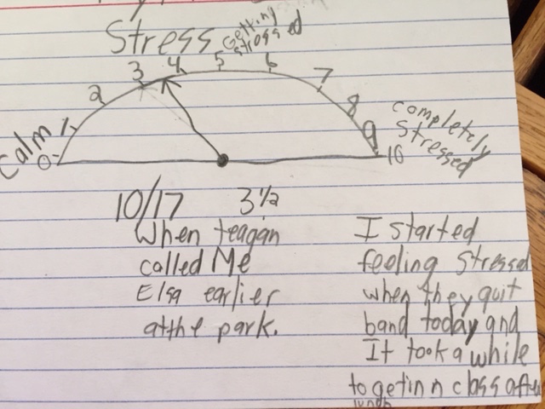

Initial class-wide stressometer students would use to monitor and reflect on their feelings of stress:
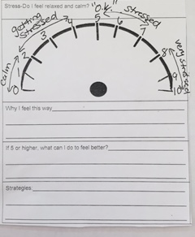

“Keep Calm and Learn On” Cycle One Journal:

“Keep Calm and Learn On” Cycle Two Journal:

Week 1 Sleep Plan:

MY PLAN/SLEEP JOURNAL
Goal Time I will go to bed_______ Goal Time I will wake up_________________Goal hours of sleep each night
Activities I will do in the 1 hour before bed:______________________________________
Sleep log
Day | Bed-wake up time | Total Hours | Activities
Sunday
Monday
Tuesday
Wednesday
Thursday
Techniques to fall asleep:________________________________________________________

Week 2 Sleep Plan:

MY PLAN
Goal 10-11 hours of sleep per night (no less than 9)
Goal time I will go to bed_______ Goal time I will wake up_______
__________goal hours of sleep each night
SLEEP LOG
Day | Bed-wake up time | Total Hours | Activities
 | ____p.m.-  ______a.m. |  | Technology (screen) snack/drink  read  play game/hobby (no technology)  Light stretching get ready for next day  other___________
Techniques used to fall asleep-circle ones you used throughout week
Breathing tense/relax muscles breathing with noise

breathing with counting visualization other_____________

Works Cited

Black, D., & Fernando, R. (2014). Mindfulness training and classroom behavior among lower-income and ethnic minority elementary school children. Journal of Child and Family Studies, 23(7), 1242-1246.

Romano, J., Miller, J., & Nordness, A. (1996). Stress and well-being in the elementary school: A classroom curriculum. The School Counselor, 43(4), 268-276.

Segool, N., Carlson, J., Goforth, A., Von Der Embse, N., & Barterian, J. (2013). Heightened test anxiety among young children: Elementary school students’ anxious responses to high-stakes testing. Psychology in the Schools, 50(5), 489-499.

Sotardi, V. (2016). Understanding student stress and coping in the elementary school: A mixed-method, longitudinal study. Psychology in the Schools, 53(7), 705-721.

The MindUP Curriculum Grades 3-5: Brain-Focused Strategies for Learning-and Living. (2013). New York, NY: The Hawn Foundation.

