Teaching to transform: Confronting bias in the eighth grade
Hannah Nolan-Spohn
ARLI Senior Fellow, 2017

“For black folks teaching―educating―was fundamentally political because it was rooted in antiracist struggle.”
― bell hooks, Teaching to transgress
Teachers are used to being asked the question, “Why do you teach?” I answer that I think teaching is the most direct way to combat racism in the world. It’s a strong statement, and not one I take lightly. The action research I conducted this year forced me to come to terms with how I define anti-racist education and what it means for me to be a White woman attempting to illuminate and disrupt structural prejudice for the students I teach.
As a special education teacher, I came to this project with the idea that inclusion needs to both address disability head-on and embrace more identities than simply the students with IEPs, or the English Language Learners. What about the LGBTQ students in my class? The students who have family members involved in the criminal justice system? What about the young people they are about to meet in high school? The Muslim students? The trans students? The students whose opinions are completely divergent from their own? I decided that I wanted to study how classroom practices can support students in expressing their diverse identities, help them accept those who are different, and find channels for their outrage at the injustices in our world.

School context
Pulaski International School of Chicago is a Level 1+ neighborhood public school located in Bucktown. It was authorized as an International Baccalaureate school for both the Primary Years and Middle Years programmes in 2013-2014. We currently have 913 students enrolled in Pre-K through 8th grade. We are one of three regional gifted bilingual centers in Chicago; one section per grade level K-8 is comprised of students from around the city who are bilingual in Spanish and English and labeled gifted.
Our school population reflects the shifting demographics of the Bucktown neighborhood. Currently, our students are 74.4% Hispanic, 16.4% White, 1.6% Asian, and 1.4% Black. However, the demographic shift is evident between the primary and upper grades, with the upper grades being predominantly Hispanic and the younger grades slightly more diverse. In addition, many of the families of students in our upper grades have moved out of our neighborhood boundaries.
According to our CPS School Profile, Pulaski’s population is 74.9% low income, including some homeless students. 15.7% of our students have limited English proficiency and we have a transitional bilingual program that services students throughout their years at Pulaski. 8.4% of our students (77 students) are diverse learners. The diverse learners’ primary diagnoses are:
- 3 students (3.9%) are diagnosed as Autistic
- 8 students (10.3%) are diagnosed with a Developmental Delay
- 4 students (5.2%) are diagnosed with an Emotional/Behavioral Disorder
- 2 students (2.6%) are diagnosed with a Mild Intellectual Impairment (Educable Mentally Handicapped)
- 38 students (49.3%) are diagnosed with a Specific Learning Disability
- 9 students (11.7%) are diagnosed with Other Health Impairment (typically ADHD)
- 13 students (16.9%) are diagnosed with Speech/Language Pathology
- An additional 41 students have 504 (medical) plans, typically for asthma, diabetes, or ADHD
The International Baccalaureate (IB) certification of our school has many implications for professional development, instructional practices, and educational philosophy. Nearly all teachers at all grade levels have participated in at least one intensive IB training, which is divided up by subject area and category, one being introductory, two being intermediate, and three being advanced. I have participated in category two training for both Language & Literature and Mathematics. Through these trainings, teachers learn best practice to construct IB unit plans, collaborate with colleagues, formatively and summatively assess student learning, design assessments with real-world context grounded in inquiry, and promote holistic student development. These practices are reflected in the IB mission statement:
The International Baccalaureate® aims to develop inquiring, knowledgeable and caring young people who help to create a better and more peaceful world through intercultural understanding and respect.
To this end the organization works with schools, governments and international organizations to develop challenging programmes of international education and rigorous assessment.
These programmes encourage students across the world to become active, compassionate and lifelong learners who understand that other people, with their differences, can also be right.
In practice, the mission of the IB programme is reflected throughout our school culture: we organize our schedule into a six-day rotation to meet minimum hours of PE, the Arts, Language B (Spanish), and Design; we acknowledge staff and students on a monthly basis for demonstrating aspects of the IB Learner Profile; we create space for grade-level and subject-level collaboration time, and periodically meet for vertical articulation through the primary and middle years programmes; we encourage arts integration, research skill acquisition, real-world experience, and service learning, which are supported through unique staff schedules, field trips, and external partnerships.
The particular context of my research is an 8th grade Language & Literature (IB terminology for Language Arts) class, a two-hour daily class which I co-teach with a general education teacher for the last hour of the the day. My co-teacher is in her 12th year of teaching, her 7th year at Pulaski. She taught 7th grade for 5 years at her previous school and has only taught 8th grade here at Pulaski. She has co-taught for 5 years with 3 different teachers. She is endorsed in Social Studies, Spanish, ESL, Language Arts, and Gifted Education. She holds an M.Ed. in Curriculum and Social Science from DePaul and BA from DePaul in Elementary Education with a double concentration in Spanish and History. She teaches 3 hours of Individuals & Societies (IB term for Social Studies) and 2 hours of Language & Literature each day. She is the recent recipient of the teacher of the year award from the Constitutional Rights Foundation - Chicago.
The class consists of 28 students, 14 boys and 14 girls (since the start of the year, 2 students have left the class - one has received an initial IEP and moved to the resource setting for Language Arts while another moved out of state, so at the end of the year there were 26 total students, 13 boys and 13 girls). 5 students have been at Pulaski since preschool, 3 students since kindergarten, 2 students since first grade, 2 students since second grade, 3 students since third grade, 2 students since 4th grade, 3 students since 5th grade, 3 students since sixth grade, 3 students since seventh grade, and 2 students are new transfers in eighth grade. Two of the students also left Pulaski in a younger grade and then returned as sixth graders.
This grade level (not just this class) has a reputation for being a rough group behaviorally. Some teachers ascribe it to the three kindergarten teachers that they had in one year (i.e., teachers quit mid-year and were replaced). Others point out a couple of students with extreme behaviors (e.g., two students with diagnosed ODD) who have a toxic effect on the group at large. My awareness of this group began when they were in 6th grade, during which time two of their teachers were on maternity leave at once, and several behavioral incidents took place while long-term subs were in place. Challenges continued in 7th grade, and have presented themselves in 8th grade. Many of the behavioral challenges manifest as immature behavior (calling out, throwing objects, getting up without permission), but have also been as severe as bullying, cyber-bullying and fights between students.
Within the class, there are six students with disabilities (5 by the end of the year). One is Autistic, three have learning disabilities, and two have emotional-behavioral disorders. An additional student has a 504 for ADHD (although they have also self-identified as Autistic, a medical diagnosis is not on file).

Literature review
In my study, I am using the term culturally-responsive pedagogy as defined by Santamaria (2009): the “purposeful consideration of the cultural, linguistic, and socioeconomic factors that may have an impact on students’ success or failure in the classroom.” (p. 9, as cited in Herrera, Holmes, & Kavimandan, 2012, p. 3). The term “critical consciousness” originates from Freire’s (1970) term “conscientização...learning to perceive social, political, and economic contradictions, and to take action against the oppressive elements of reality” (p. 17). Finally, I am using the term inclusion to represent the physical inclusion of students with special needs in a classroom with students without special needs, the inclusion of students’ identities and experiences in the curriculum, and the inclusion of reflections on my attempts to enact anti-racist, social justice practices in the classroom. I organize the review of literature into four sections: the self, the other, problems and actions, and instructional practices.

A. The self
Culturally-responsive pedagogy must begin with student knowledge of self, an exploration of identity, the use of personal narrative, and teacher respect for the individuals in their class. Picower (2012) sets out “Self Love and Knowledge” as the first step in a six-step framework for social justice education in the elementary classroom (p. 5). In addition to allowing students to better know themselves, teachers must make knowing students a priority. Herrera, Holmes, & Kavimandan (2012) use the term “Biography-Driven Instruction” to honor the culture, language, and life experiences of students (p. 4). Similarly, hooks (1994) describes how her Black teachers “made sure they ‘knew’ us. They knew our parents, our economic status, where we worshipped, what our homes were like, and how we were treated in the family” (p. 3). Particularly in multicultural settings, and when the teacher’s culture differs from her students’, it is vital that the teacher show respect for the lives of her students. In their meta-analysis of thirty scholarly articles on culturally responsive practices, Piazza, Rao, & Protacio (2015), emphasize that respecting the lived experiences and inherent strengths of students is the foundation for best practice (p. 3). Kearns (2012) applied her background in clinical talk therapy to illuminate the power of narrative in helping young people find their voice (p. 26). Similarly, Christensen (2012) saw that in order to “validate students’ experiences” she needed to help them learn how to write personal narratives (para. 3). Thus, personal narratives, explorations of identity, and invitations to share life experiences are the foundation of the curricular choices I made. I also used the framework of Universal Design for Learning (i.e., intentionally planning to meet multiple modalities, interests, and learning challenges) to ensure that I accommodated the diverse academic, social-emotional and linguistic needs of my students as I planned instruction.

B. The other
Social justice education must go beyond students understanding and finding pride in their own heritage. In order to work towards justice, we must see the humanity in people who are different from ourselves. Students need to be able to move beyond stereotypes about groups and see all that they share in common with individuals from different backgrounds. As Chimamanda Adichie cautions, “The single story creates stereotypes and the problem with stereotypes is not that they are untrue, but that they are incomplete” (as cited in Christensen, 2012, ‘Unwieldy Influences’ section, para. 1). Picower (2012) emphasizes that students are drawn to understand injustice when they appreciate and respect the uniqueness of diverse groups who have experienced unfair treatment (p. 7). Students must be given opportunities to hear the first-person experiences of people with different backgrounds and life experiences. Through news accounts, songs, documentaries, photography, and first-person narratives, I wanted to help students learn about and empathize with others. This effort to create curriculum that honors multiple perspectives is a deliberately political move, acknowledging what Delpit (1995) described as “the power of the publishers of textbooks and of the developers of the curriculum to determine the view of the world presented” (p. 24). Instead, I am interested in creating curriculum that helps students recognize the pervasiveness of stereotyped and inaccurate portrayals, while giving them tools to disrupt (or at least complicate) those worldviews.

C. Problems and actions
Social justice must always be rooted in a drive to act. This complements my students’ experience of the International Baccalaureate (IB) Programme, which puts inquiry, action and service at the center of learning to be a well-rounded person. When students learn about marginalization, oppression, and injustice, they need an constructive outlet for their outrage. Otherwise, they can tend towards fatalism and hopelessness (Freire, 1970, p. 43). They need to study examples of youth movements, civil rights direct actions, and multi-faceted approaches to social change. When provided models, structures, and organizing tools, young people learn that “when something is unfair, responsible and caring people do something about it” (Picower, 2012, p. 12). They must be pushed to move beyond fundraisers or charity and risk what Freire (1970) calls “an act of love” (p. 32) and Picower (2012) describes as “rooted in justice” (p. 3). If they have embraced the other as fully human, and experienced their suffering not as something to be pitied but as an affront to humanity, students can act in transformational solidarity. As Delpit (1995) encourages, “teachers must allow discussions of oppression to become a part of language and literature instruction” (165). This will not step outside the curriculum, but weave into it.

D. Instructional practices
Best practices for culturally-responsive pedagogy are truly best practices for teaching and learning. Piazza, et. al., (2015) find diverse groupings, inquiry, dialogue, collaboration, vocabulary instruction, and visual literacy to be the cross-cutting practices in their meta-study (p. 6). Herrera, et. al., (2012) similarly emphasize collaboration, strategic groupings, and instructional conversations as best practices for culturally diverse students (p. 11). Christensen (2012) used mentor texts, modeling, peer support, and collaboration to engage students in lessons that taught “students to read and write while also examining the ways race and class function in our society” (para. 5). In my study, I enacted these recommendations by varying groups to provide support and collaboration opportunities, teaching students how to co-construct meaning through dialogue, providing explicit vocabulary instruction and native language support, and promoting access to challenging content by providing visual supports. Finally, much as students benefit from knowing the objective of a lesson in advance, I am inspired by Kearns’ (2012) transparency with her subjects in describing her research aims (p. 29) and sharing her data with them (p. 37). I sought to be similarly open with my students about the goals of my project and the data I collected along the way. I teach because I believe it is the most direct way to enact anti-racism and disrupt systems of oppression. I owe it to my students to show them why I’m here.

Question: What happens when I use culturally-responsive teaching practices?

Subquestions:
- What teacher choices engage students?
- How do students respond to injustice?
- Why teach controversial topics?

Summary of data collection methods
- Student work samples - photographs of student notebooks, data about grades on assignments, scanned copies of student work samples, data on the choices students make when given a choice in an assignment, student responses to survey questions.
- Records of class discussions - scripts of small group conversations that I sit in on, small group minutes on the highlights of their conversations, diagrams of whole-group conversations with a seating chart, codes for type of comment and lines connecting the flow of conversation, notes about whole group conversations written on the board then photographed afterwards, scores for student responses and comments on the online discussion forum (Google Classroom).
- Teacher journal - reflections on planning sessions with my co-teacher including what texts we selected to present to students and why, reflections on how class went, thoughts about individual students whose reactions are notable or challenging.
- Student data - quarterly grades, standardized test scores (NWEA), attendance records, special programs (ELL, IEP, 504, MTSS).

Data and interpretation
In order to see relationships between class participation and other data points, I used the student participation data for ten class discussions that took place from September 2016 to February 2017. Based on whether or not students participated in the discussion at all (accounting for absences), students fell into one of three categories:
- Low participation - 6 students (5 by end of year) participated 0-50% of the time
- Medium participation - 12 students participated 51-99% of the time
- High participation - 10 students (9 by end of year) participated 100% of the time
While these categories do not account for the frequency of comments in an individual discussion nor the quality of these comments, they do provide a framework for viewing which techniques and topics engaged students who are more or less inclined to speak in class.

Section 1: What teacher choices engage students?
In this section, I describe how I arrived at the specific content selected to add to the curriculum, how students chose elements of the curricular content, how I decided to incorporate different formats of class discussions, and students’ choices related to discussion format.

1A. Teacher choices - Content of class discussions
Over the summer between 7th and 8th grades, students were asked to complete a research paper on a problem they found important. We noticed an overwhelming majority focused on police brutality, racism, and deaths, including specific references to the Black Lives Matter movement. In addition, upon surveying students on the first day of school, we found that students expressed concern about racism, prejudice, and violence. Thus, my co-teacher and I decided that we needed to start with current events around the Black Lives Matter movement, police shootings of young Black men in particular, and the protests that had been taking place over the summer, including Colin Kaepernick’s National Anthem protest. We thought that by taking controversial issues, providing some background knowledge, and opening up space for discussion, we would engage a group of students that had come with a reputation for being difficult to teach. I learned that connecting to current events is a great way to bring life to old units and help students discuss issues they are seeing or hearing about in a constructive way (see Framework #2, p. 41).
We set out to revise our curriculum, particularly our non-fiction texts, to respond to students’ interests, analyze current events, and provide exposure to groups that our students may not interact with on a daily basis. We selected texts that fit into our existing thematic units and tied into novel studies, when possible. 13 out of 20 texts studied from September to March were new to our curriculum, showing our responsiveness and desire to adapt to our students and the current social and political context. We did not, however, change the overall unit structure, statement of inquiry, or anchor texts, leading me to realize that when revising units, it’s important to not reinvent everything, but build on the existing unit structure (see Framework #6, p. 41).
We planned to integrate several texts of different formats that would address the Black Lives Matter movement as well as different forms of public protest. As I noted in my teacher journal on October 12, 2016:

We’ll be analyzing Jamila Woods’ song “VRY BLK,” watching two videos of youth slam poets from Louder Than a Bomb and Brave New Voices, and reading a news article about Colin Kaepernick. I’m also interested in...finding an excerpt or quote from Ta-Nehisi Coates’ Between the World and Me.

The integration of different text formats provided access points for students to engage with thematic content. Students were assigned a written task, to explain how two different text expressed a common theme, and had seven texts to choose from: a novel, two news articles, a poem, a song and two spoken word pieces. Students choices are shown in the table below.

Text | Number of times chosen
VRY BLK (song) | 13
Brave New Voices (spoken word) | 13
Blue & Black (news article) | 11
Star-Spangled Protest (news article) | 7
Nothing Gold Can Stay (poem) | 5
The Outsiders (novel) | 2
Louder than a Bomb (spoken word) | 1
Total | 52 (26 students x 2 choices each)

Clearly, students responded most strongly to the song and spoken word piece, and were best able to understand how those pieces reflected themes of police violence, racism, and the loss of innocent lives. This experience led me to consider that the variety of text types (songs, spoken word, video, etc.) is essential to engaging students in challenging topics (see Framework #4, p. 41).
Although there were many possible identity groups that we could introduce, we often tried to find a blend of something in the news and something that students could hear multiple perspectives on. Finding a photographic series was a way to practice visual literacy and help students make inferences. I noted in my teacher journal on October 26, 2016:

Our next topic is Muslim women. Yesterday we read a news article about the French burkini ban, and we discussed it today. Tomorrow we are going to analyze a photograph by a Yemeni woman that addresses the veil...After that, we’ve got a short video about a Muslim woman doing community organizing in Brooklyn…

As the project went on, I found a constant struggle between trying to choose pieces that fit in with unit themes and trying to find pieces that I thought would provoke students to think about a different demographic of our society. One unexpected population we ended up addressing was prison inmates. It ended up being a great bridge between our novel study, Monster by Walter Dean Myers, and our unit on food justice, as we learned about the ongoing prison strikes over prisoners making less than the minimum wage, and the fact that grocery stores like Whole Foods have been criticized for selling products manufactured using prison labor.
I worked to find ways to return to my research focus on identity after reading a class novel, as I often felt that I had “missed” data collection opportunities during the weeks of our novel studies. As I reflected in my teacher journal on February 7, 2017:

After reading Of Mice and Men, we typically spend some time exploring how people with disabilities are treated in our society. I wanted to specifically focus on Autism this year. We showed a 15-minute video created by a high school student, that offers a very well-researched empathetic overview of some of the challenges faced by Autistic teens. In order to offer a second perspective, I gave the students an excerpt from a speech by Jim Sinclair.

Later, we read the short story “The Country of the Blind” by H.G. Wells to try to introduce the idea that disability is a social construct.
After providing some student choice (discussed below), it became apparent that there were many questions - and a great deal of misconceptions - about the trans community. Thus, we decided to focus our final identity study on trans youth, connecting explicitly to the 1960s Civil Rights movement the students were learning about in Individuals and Societies class (Social Studies), as well as providing a combination of news articles, infographics, videos, and profiles of trans youth. Observing student language and noting their interest led me to consider that choosing which groups of “others” to study should be based on the prejudices, stereotypes, and misconceptions that students voice. Rather than punish students who say something problematic, we can take it as an opportunity to educate (see Framework #3, p. 41).

1B. Student choices - Important issues
We provided two explicit opportunities for students to choose an issue to study during the course of the year. The first was based on a quick survey I gave in March. Students were asked to identify what one issue bothers them most. They could select one of 12 issues they had identified back in September, or fill in “other.” The results are shown in the table below:

Topic | Number of Students
Racism/Prejudice | 9 (split into two groups)
Police Brutality | 3
Sexism | 3
Animal Abuse | 3
Discrimination against LGBTQ Community | 3
Homelessness | 2
Violence/Guns | 2
Religious Intolerance | 2

Again, students overwhelmingly identified racism and prejudice as issues that are extremely important. The other groups were fairly evenly split. All students had the opportunity to teach their peers about the issue they chose and learn from their peers about some of the other topics. As mentioned earlier, the discussion of discrimination against the LGBTQ community, which focused on the struggles of a young trans girl to be accepted by her family, school, and community, elicited the most dynamic small group discussions, which prompted my co-teacher and I to teach a week-long mini-unit on trans youth.
A second opportunity for student choice was provided at the beginning of May. Students were asked to select one social issue they care about, and write a short research paper explaining the problem, two organizations/groups that are helping to solve the problem (one had to be local to Chicago/Illinois), and why we should care about the issue. I provided a model text by writing a research paper about the exoneration of wrongfully convicted individuals, and the university-based groups of lawyers, journalists, and others who support these innocent people in finding justice. Students choices for these papers are shown in the table below:

Research Topic | Number of Students
Obesity | 4
Gang Violence | 3
Gun Violence | 3
Homelessness | 3
Abortion | 2
LGBTQ Discrimination | 2
Suicide | 2
Animal Abuse | 1
Domestic Violence | 1
Deportation | 1
NFL Concussions | 1
Police Brutality | 1
School Funding | 1
Women’s Sports | 1

While some of these topics (police brutality, LGBTQ discrimination) connect with themes we have explored in class, most were personal choices made by the students. Obesity seemed to be a popular choice because the day we asked students to brainstorm topics, their PE class had watched a documentary about sugar, obesity, and diabetes. In some ways, teens are highly open to suggestion. The important thing is that students chose a topic that they care enough about to research thoroughly and write about with passion. This is another moment in which I felt the importance of valuing the students’ identities, including the issues they feel passionately about (see Framework #1, p. 41).
Observing students as they worked on their research paper gave me a great sense of accomplishment. Some students were very eager to share their findings as they conducted their research. As I noted in my Teacher Journal on May 5, 2017, Genevive was expressing outraged that the average jail time served for domestic abuse is only 30 days, and was quoting statistics to Cole, seated next to her, making comments such as, “I just can’t even believe this!” Later, Kimberly walked up to me and said, “Did you know that there’s a suicide every 13 minutes? 113 every day?” She was shocked by the information she was reading and needed to share it. How purposeful they must feel, to be learning about a topic they care about. These comments also show their innate need for an audience. They have learned about an injustice and need others to know and share their outrage.

1C. Teacher choices - Discussion format
At the beginning of the year, my co-teacher and I noticed that some students participated actively and passionately in whole-class discussions while others sat silently and made no comments whatsoever. As I noted in my teacher journal on September 29, 2016:

The class was 50-70% engaged. My co-teacher noticed that even students having side conversations were very much on topic, though this was challenging to the overall group dynamic. Upon reflection, I think that our next session... we will do in small group to facilitate stronger participation and help it not be dominated by just a few students.

Although my co-teacher and I were not willing to completely abandon the whole-class model, we did quickly start to implement a variety of heterogeneous and homogeneous small groups. In addition, after the prompting of some of my ARLI colleagues to consider the introverts (and a particularly frustrating small group in which two students refused to speak), we added the online discussion forum, testing it out with the whole class twice and using it once as an option students could select. I elaborated on my thought process in my teacher journal, dated January 6, 2017:

I wonder if taking out the time element...like, instead of having a real-time conversation, we have a google classroom conversation like the way an online forum would be. Students have to post, respond, reply to responses, but it doesn’t have to happen in real time. That can give kids the opportunity to formulate their thoughts or do additional research and removes the aspect of putting kids on the spot to speak aloud, publicly. I wonder if that might bring out some of our more reluctant participants (and whether our more vocal students would really hate it).

The table below outlines the variety of discussion formats used from September-March and the average participation for each format.

Discussion Format | Number of Times Used | Average Participation
Whole Class | 4 | 66%
Small Group - Random | 2 | 93%
Small Group - Deliberate | 2 | 93%
Small Group - Student Choice | 1 | 100%
Silent/Written Discussion | 1 | Data not collected, probably 100% based on observation
Online Discussion | 3 | 100%
Philosophical Chairs | 1 | 48%

The variety of discussion formats was deliberate, in order to increase participation. The silent/written discussion is a format I’ve used many times, as are small groups (both random and selected for a deliberate reason). Two formats that were new to my pedagogy this year were the online discussion and philosophical chairs. Although adjustments could be made to try to improve the experience, I feel that the extremely low participation and overall feedback from students would not make me want to try philosophical chairs again. On the other hand, the online discussion format was extremely successful in generating participation. The next graph breaks down participation into average student comments by group.

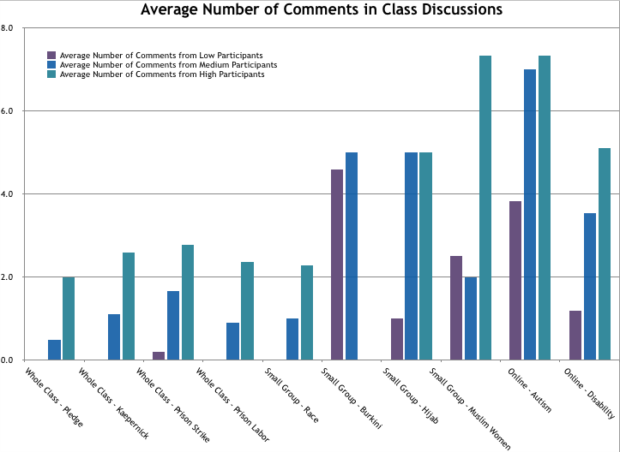

The graph “Average Number of Comments in Class Discussions,” above, tallies the number of comments or questions posed by each student in a series of 10 class discussions recorded between September and February. By definition, the students in the high participation group participate the most, so it’s not surprising to see that the teal bar is the highest for almost all conversations. The gap in the data - that there are no high participants in the Burkini small group - exists because data was not collected for all small groups simultaneously, so only data available for the participants in that particular small group is included. It is striking that the difference between high and medium participation groups is tiny for the first online conversation about Autism. In fact, all three groups showed a peak for that online conversation - in which all students were required to participate online. The second online conversation - about disability and minimum wage - showed more of the expected pattern of low-, medium- and high-participants contributing to the conversation. In addition, the medium and high participation groups had equal participation in the Hijab small group conversation, while both the low and medium participation groups had a peak in the Burkini small group.
The medium participation group seems to perform well in both small group and online settings. This makes sense - they aren’t being “drowned out” by the high-frequency participants in small groups and are able to comment as much as they wish, and in the online setting, there isn’t the issue of only one person being able to talk at once - they can all be commenting at the same time. In fact, 19 students had their best participation to date in one of the two online forum conversations. A particularly interesting interaction took place between the student who self-identified as Autistic during that class period (and who is in the medium-participation group), another medium-participation student, and a student in the high participation group. The three do not typically interact socially or in class, but engaged in an interesting thread, part of which is highlighted in the figure below.

Question: What might you infer about the author, Jim Sinclair, after reading “Autism is not an impenetrable wall?”

Javier
I think that Jim Sinclair has autism himself. I also have autism and it sometimes feels like a impenetrable wall because sometimes I feel like i dont fit in. I think that he is a parent of kids that has autism and might feel how it is having a kid with autism. I think that he has hard times communicating with his children or maybe when he was a kid he had trouble with his social skills.

Hannah Nolan-Spohn
Thank you for sharing your perspective! Is there a particular sentence or passage of the article that makes you draw this conclusion?

Javier
The part when it is says parent-child relationship. I also know this because I know how it sometimes for my dad too deal with me with my autism.

Alberto
I don't think Jim Sinclair has autism himself. It seems as if he's an advocate instead.

Javier
ohhh

Bethany
Alberto, I agree with what you said but I think he has a kid with autism because like you said Javier parent -child relationship and this shows how he has a kid with autism also because of how he explains how it's hard to relate.

The low participation group also benefits from both small group and online settings, though it’s no surprise to see that they still comment less than their peers in the medium and high participation groups. In addition, the low participation group makes no or close to no comments when in the whole group setting. For the Pledge, Kaepernick, Prison strike, and Prison Labor conversations, those six students sat silently almost the entire time.

1D. Student choices - Discussion format
On March 1, 2017, for a conversation about the themes of the H.G. Wells story, “The Country of the Blind,” which we had read and discussed in class, students were given the choice of participating in an online or in-person conversation. The class was split pretty evenly, although it was interesting to see that some low participation students chose the in-person group, while some high participation students chose the online group. The table below illustrates student performance for this discussion.

Participation Group | Chose Online Discussion | Chose In Person Discussion | Met or Exceeded Expectations on 3-1-17
Low | 5 of 6 | 1 of 6 | 1 of 6
Medium | 5 of 11 | 6 of 11 | 7 of 11
High | 3 of 10 | 7 of 10 | 7 of 10
Total | 13 of 27 | 14 of 27 | 15 of 27

The expectations for the online and in-person formats were slightly different, to account for the fact that only one person could speak at a time in the in-person conversation. Expectations were clearly communicated to students. In the online forum, students needed to provide two original answers to any of the four questions posed, and post at least two comments on others’ posts. For the in-person conversation, students were asked to join in the conversation at least twice (either by answering a question, commenting on another’s answer, or making a connection).
The only person in the low-participation group who met expectations for that conversation (in other words, gave at least two comments or questions) was precisely the student who chose to join the in-person conversation. The other 5 low-participation students, all of whom selected the online forum, did not meet expectations; these students only answered questions without engaging in commentary on others’ posts.
In the medium participation group, 5 of the 6 students who chose the in-person discussion met or exceeded expectations. The only student who did not meet expectations, because they only commented once, had an overall average participation of 71%, and demonstrated their best performance in the online discussion of Autism. Perhaps they would have done better if they had elected to participate in the online forum. However, only 2 of the 5 students in the medium participation group who chose the online discussion met expectations. Out of the other students, two only answered questions without commenting on others’ answers, and one student commented just once. One student from this group was absent on the date of the discussion.
In the high participation group, I was surprised that three students chose to participate in the online forum, since they had 100% participation in all previous whole and small group class discussions. Interestingly, those three students were not able to meet expectations for participation in the online forum. All 7 high participation students who opted for the in-person discussion were able to meet or exceed expectations for participation.
To sum up, although providing students with choice of discussion meant that students who don’t speak up frequently chose to participate in an online forum, they still did not tend to meet expectations. On the other hand, removing the students who have low participation from the in-person group created a more dynamic conversation, in which nearly all members met expectations. I learned that varying the style of discussion allowed for different students to participate and feel more comfortable, which has become an important feature of my planning (see Framework #5, p. 41).

Section 2: How do students respond to injustice? Why teach controversial topics?
When I set out to start this research project, I was thinking about themes of inclusion. As it turned out, my focus shifted more towards shifting perspectives, addressing biases, and helping students be more critical of assumptions, stereotypes, and monolithic views of “others.” I wanted to choose texts, discussion formats, and activities that can function on multiple levels. Upon reflection, I can see that I was developing a framework for selecting texts that fit within an anti-bias framework. Some of the criteria I considered included:
- Sharing a theme with our unit of study and class novel
- Analyzing current events and social problems
- Addressing microaggressions, misconceptions, or prejudices voiced by students
Within this framework, I sought to transform the class environment into a space that allowed for critical analysis of political and social structures of power and encouraged students to see relationships between themselves and “others” (see Framework, p. 41).
In the following section, I describe how the new content I selected changed the class environment, how it impacted student achievement, and how it failed to reach certain students.

2A. Transforming the class environment
Throughout the year, themes of socially-constructed difference, power and prejudice were addressed through a variety of topics. Within each unit, there is evidence that students grew to understand the common humanity of diverse groups, and increased their ability to recognize bias and injustice.
In this section, I describe the new content that I selected for each topic: #BlackLivesMatter and Police Brutality, Muslim Women, Prisoners, and Disability (specifically Autism). Within each topic, I provide evidence of student work, excerpts from my teacher journal, analysis of what was successful or unsuccessful, notes about how students went beyond the classroom to engage with the topic, and what I have learned about my practices by reflecting on the work.

2A1. #BlackLivesMatter and Police Brutality: With a lofty goal to help students see the structural racism in the police force and understand why “All Lives Matter” is offensive and missing the point, we did the following work:
- read three articles: “Blue and Black” by Jack Healy and Nikole Hannah-Jones, Upfront Magazine,“Star-Spangled Protest” by Carl Stoffers, Upfront Magazine, and “State of emergency in North Carolina as protests turn violent” from the Charlotte Observer;
- looked at a news photo of Ieshia Evans standing before riot police in Baton Rouge;
- analyzed a song, “VRY BLK” by Jamila Woods;
- watched videos of two spoken word performances, one by the Washington, D.C., team at the 2013 finals of Brave New Voices and one by an Englewood, Chicago team from 2014 Louder Than a Bomb; and,
- analyzed a quote from Ta-Nehisi Coates’ Between the World and Me.

Student responses to this work were powerful. On October 12, 2016, while we were discussing the “Blue and Black” article, Adrianne said, “I don’t know why we’re doing this. It’s pointless.” She was frustrated that we kept talking about protests but nothing seems to be changing. Rose replied, “It’s not pointless because someday we might be mayor or senator or president.” Rose’s optimism and drive to be an agent of change lifted the class when we might otherwise lose hope. Kimberly added, “What are we going to do about this now?” Her comment prompted students to start brainstorming tons of ways that people can be involved in raising awareness about racism and police brutality.
On October 17, 2016, while analyzing the song “VRY BLK,” Cortez helped the class recognize that the line “If I say that I can’t breathe/Will I become a chalk line?” was in reference to Eric Garner. His ability to connect our studies in class to other texts, events, and songs was a great asset to class discussions throughout the year. As we listened to the song a second time, some students were trying to interpret the noise at the beginning of the song. Jackie exclaimed, “It’s a heartbeat! It’s an innocent baby in an ultrasound!” She was able to connect an abstract sound to the theme of the song - the loss of innocent lives - in a way that helped make the theme apparent to her peers. Both of these examples reveal how having class discussions about controversial topics, although participation may not ever be perfect, allows different students to bring in connections and interpretations that their peers may have missed, which enrichens everyone’s experience.
In addition, the shared inquiry into prejudice created an environment in which students grew comfortable calling each other out when they expressed a judgemental perspective. On October 19, during a discussion of Colin Kapernick’s protest during the National Anthem, Jeremiah made the comment that all Whites are racist. Kimberly called him out, saying not all Whites are racist. Jeremiah corrected himself and said “not all, but most.” Genevive defended him. Kimberly felt confident to confront him when he expressed a monolithic view of a group of people. Incidentally, I agree with Jeremiah, and think this was a “not all White people” moment, which isn’t actually productive, because it is all White people. That’s the definition of Whiteness. As Ta-Nehisi Coates says, “race is the child of racism, not the father” (p. 7). Even if I disagree with her personally, this was an example of a student feeling empowered to challenge her peer to be more open-minded.
On October 20, 2016, I pulled a small group of students with high participation to discuss a quote from Ta-Nehisi Coates’ book Between the World and Me. The quote was, “In America, it is traditional to destroy the black body--it is heritage” (p. 103). Among several insightful moments, in which the students spoke to each other while I observed and took notes, Kimberly turned to me and asked, “Why are we talking about this?” She gave me the opportunity to explicate my framework - it’s in the news, it’s provocative, and to reveal that I consider it my purpose as an educator, that we must discuss race if we are going to overcome racism.
At the close of this work, and after finishing our class novel, The Outsiders by S.E. Hinton, students were asked to analyze two pieces that shared a common theme. Our hope was that they would be able to recognize the theme of innocence/loss of innocence or the idea of outsiders/prejudice. The work was not entirely successful.
Students could choose any 2 of the texts, with two exceptions: if they chose The Outsiders they couldn’t also choose the poem “Nothing gold can stay” since the poem is contained in the book and the comparison would be too surface; they also were not allowed to choose both spoken word pieces because they didn’t have the videos to re-watch and therefore couldn’t provide direct text evidence, only paraphrases. Data is only for 26 students, because one student refused to complete the task, and another was absent and never turned it in.

Text | Number of times chosen
VRY BLK (song) | 13
Brave New Voices (spoken word) | 13
Blue & Black (news article) | 11
Star-Spangled Protest (news article) | 7
Nothing Gold Can Stay (poem) | 5
The Outsiders (novel) | 2
Louder than a Bomb (spoken word) | 1
Total | 52 (26 students x 2 choices)

I was pleased to see that students chose to work with the song and the spoken word piece. This tells me that the multi-media approach to unit themes is effective. It’s interesting that so few kids chose the novel, when we had worked explicitly with theme in class, and they had a chart in their notebooks with three different possible themes of the novel, along with evidence from the text.
After scoring their responses with my co-teacher, I noticed a clear trend of misinterpreting the assignment - many students described two completely different themes of the two texts they chose. The other trend was for students to confuse topic and theme. Many of the latter group stated that the common theme was police brutality. Their grades are below:

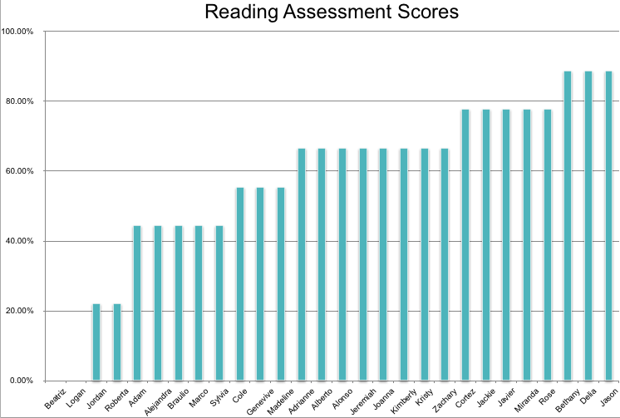

Given that only 8 of 26 students scored a C or above, students did not demonstrate mastery of the skill of comparing two themes across different texts. However, even within the pieces that were not entirely successful, there were a few moments that showed me that they did have some understanding of the deeper meaning behind these texts, i.e., the link between different forms of prejudice, the loss of innocent lives, and the societal separation between insiders and outsiders.
Adrianne, who scored 67%, said “It’s important to understand b/c yes we’re all different, but not in a bad way. Everyday someone is picked on b/c of race, looks, how we love, etc.” She was able to make the connection between discrimination against Blacks by the police and other forms of prejudice, including homophobia and sexism.
Braulio, who scored 44%, was able to pull out the larger theme of innocence, focusing on the fact that both “VRY BLK” and the Brave New Voices spoken word piece referred specifically to children or babies. As Braulio stated, “In line 26 it says, “I know a couple babies gon’ see ‘em fly tonight.” While he did not use text evidence or complete his ideas, he was making a strong connection between the two texts.
Adam, whose score of 44% was entirely due to him not finishing the assignment, wrote “the theme…[is] separation...In...“Blue and Black” the article talks about separation of the African Americans and the Whites...In the book, Outsiders the theme is separation of the gangs named the Greasers and the Socs.” This was probably the most insightful answer, and the kind of connection we were hoping more students would make. Unfortunately, he lacked text evidence and did not develop his ideas beyond a paragraph.
One lesson that my co-teacher and I learned, upon reflection on this assignment, was that it was better to present a theme to students and ask them to argue evidence about it, rather than ask them to come up with a theme on their own. Later, when students analyzed Monster by Walter Dean Myers, we provided the theme of “loss of innocence” and gave them three sections of the book to specifically find text quotes. We repeated this idea of providing the theme and location of evidence, leaving the selection of quotes and interpretation up to the students, when we read Night by Elie Wiesel. For that text, we gave students a choice of four different themes, allowing them to choose to explain a theme that they best understood. Asking middle schoolers to independently identify a theme seems to produce work that either identifies a topic or provides a bland, generic theme (i.e., “choices,” or “challenges.”) By providing the theme up front, we could focus on assessing whether or not students could explain how a theme is revealed in a text.
Outside of the planned curriculum, students showed engagement with these topics in a few ways. Kimberly, for example, came to my co-teacher and myself later in the year to share a video about race that she wanted to share. She asked if we would show it in class, and we did. The fact that she was thinking about a class discussion outside of school, found an additional resource, and shared it with us, shows that we engaged her in valuing the conversation about race and racism beyond completing assignments. Alonso, who often hung back in group conversations but always had a lot to say in writing or one-on-one, approached me after we studied Jamila Woods’ song “VRY BLK” to ask if I knew the rapper, NoName, who did one of the verses, and if I knew another song that she rapped on with Chance the Rapper. This began a year-long exchange of musical recommendations, with Alonso suggesting a rapper, song, album, or video for me to check out every few weeks, then following up to ask if I’d listened yet and what I thought. This engagement, through music that addressed racism, violence, and suicide, among other topics, was an authentic teacher-as-student and student-as-teacher relationship, in the model of Freire. Alonso always had a new text for me to study and made me accountable for my thoughts on each new piece.

2A2. Muslim Women
We decided to study Muslim women, specifically, because they are a group that are frequently stereotyped, that is not represented in our student population, and because the issue of France banning the full-coverage bathing suits was in the news. We studied the following pieces:
- the “Veil/Hijab” photography series by Yemeni photographer Boushra Almutawakel;
- the news article “Why did France ban a bathing suit?” by Patricia Smith, in the October 10, 2016 issue of Upfront magazine; and
- a video about activist and organizer Linda Sarsour.

A major takeaway for all students was to understand that the act of being told to cover and the act of being told to uncover are equally oppressive for Muslim women. Students were able to conclude that all women should have the power to decide what they feel comfortable wearing, and that it is a basic human right to determine what is clothing feels appropriate.
During a small group discussion of the Burkini ban article, Joanna stood out with her analysis of the anti-feminist nature of the French police’s actions. She said there is “no reason to tell them what to wear” and “it’s your body, it’s your culture.” Jordan engaged with her in a critique of these judgements being made in a public space, saying “I don’t like that they make you leave the beach...they’re making you leave a public place.” Beatriz reiterated some stereotyped views of Muslim women as oppressed, forced to wear a burka, and marrying young. It’s not clear that this conversation helped her move past that single story, to acknowledge that covering is also a valid choice that women can make.
In the next small group conversation about the Hijab/Veil photography series, I kept track of a heterogeneous group’s conversations. The results are below:

Student | Average Participation | Participation in Hijab/Veil Discussion on 10-27-16
Joanna | Low | 1
Alonso | Medium | 3 (was trying to speak 1 more time)
Adam | Medium | 3 (was trying to speak 2 more times)
Adrianne | Medium | 7 (yelled over everyone at least once)
Andres | High | 2
Miranda | High | 8

Alonso, as seems to be his pattern, talked first and then hung back a bit. He seems to like to get his idea in first so that he doesn’t feel he has to compete. Joanna agreed with Miranda but did not add anything new, which was disappointing considering her insights in the previous discussion about the Burkini. Adam, who in the previous conversation said nothing, kept trying to jump in but would get talked over or ignored by Miranda and Adrianne, who dominated the conversation. Adrianne yelled over the other group members, which is not unusual for her, even in whole group conversations. Andres’ participation was unusually low, but he has expressed views at other times that indicate he is less comfortable talking about gender stereotypes and sexism than other topics.
When each small group shared out their big takeaways from the study of the Hijab/Veil photography series, the following powerful insights were shared:
- “Mom’s hand moves across daughter--losing sense of security, protecting” (Cortez’s group)
- “Bright clothes, happy-->darker clothes, sad” (Jason’s group)
- “Working backwards from present day to the past--not connected with outside world-->happiness” (Genevive’s group)
- “Last picture symbolizes that covering=losing part of themselves-lose their personality” (Miranda’s group)
- “Family, hijabs changing in each picture-->symbolizes feminism” (Jackie’s group)
Each group was able to interpret the symbolism of the photographs and connect the visual images to larger themes of oppression and power, including the right to choose for oneself, the fear of authoritarian control, and the right of women to be able to express their own identity.
Our final piece on Muslim women was meant to break down the stereotype about Muslim women being passive. We watched a video about activist Linda Sarsour, who talks about being Arab-American, having an arranged marriage, working with youth development, and supporting cross-cultural understanding, particularly after 9/11. The students were able to connect her words to the analysis of the previous two texts, and that both being forced to cover or forced to uncover are equally oppressive. As Braulio stated in a small group conversation, Sarsour wants us to challenge our “assumptions” about Muslim women. Genevive went on to say that “Linda wants [young Arab-Americans] to feel free, not all have the same ideas about it.” The importance of self-determined choice was apparent to the students, as Rose summarized: “girls are degraded for what they wear, called out for too much or too little skin.” This was a point of connection, particularly for the young women in the group who have been the victims of gendered dress code enforcement.
We could have spent more time on this topic, and explored other stereotypes about Muslims. It’s vitally important, in our increasingly polarized country, that we spend time dismantling dangerous stereotypes about Muslims. Students are exposed to so many oversimplified views and prejudiced statements, we must take the opportunity to study this group, in particular, in order to disrupt racist perspectives.

2A3. Prisoners
After reading Monster by Walter Dean Myers, in order to bridge a connection to our interdisciplinary food unit, and because the nationwide prison strike was in the news, we chose to look at the living conditions of inmates in the U.S., specifically focusing on their ties to the food industry and concerns about low wages. We studied the following texts:
- “‘This is slavery:’ U.S. inmates strike in massive protest” by Jaweed Kaleem, in the November 4, 2016, Los Angeles Times, as adapted by the website Newsela; and
- “Whole Foods Suppliers Defend Using Prison Labor” by Susanna Kim, published October 5, 2015 by ABCNews.com.

We asked students to discuss whether or not prisoners should receive a minimum wage. In our first conversation, it was clear from several comments that students believed that most people in prison deserve harsh treatment, and several students alluded to them “being there for a reason,” or knowing what they did was wrong. Several other students claimed that if prisoners get food, shelter, and a job, that must encourage people who are homeless to commit a crime so that they could go to prison. It was obvious that many students were ignorant about the realities of our criminal justice system.
In our second conversation, we assigned students to a stakeholder group and required them to work together to prepare an argument, with evidence, to answer the question: Should Whole Foods sell items produced by prison labor? We conducted this conversation in the style of “Philosophical Chairs,” In which each stakeholder group tried to present their position and then provide counterarguments to the other groups’ positions.
This conversation was not particularly successful, I think because the format was different but perhaps not clearly defined by me, and because it requires advance preparation. Overall, most students who prepared for the discussion (scoring 6 out of 8 or above on their graphic organizer), tended to participate, while most students who did not prepare (scoring 5 out of 8 or below on their graphic organizer) did not participate. This reinforces the connection between engagement in class discussions and overall reading grades. Students who value the work, are interested in it, or want to do well are more likely to be the students who have something to say during the class discussion. I think that students who either aren’t interested in the discussion or know in advance that they’re not planning to speak have no motivation to try to complete the work of preparation.
Out of the students who did prepare, a few standout comments on their graphic organizers reveal their understanding of the deeper issue with low wages in prison:
- Kimberly: “I think it’s wrong to enslave these poor inmates.”
- Roberta: “Working with no pay is slavery.”
- Cortez: “Inmates are paid an outrageously low amount of money in prison.”
- Jason: “Inmates should receive basic rights and being paid a right amount of money is one of them.”
Moving from the initial conversation about prison strikes, in which several views of prisoners as not entitled to basic human rights and not deserving payment for their labor, the quotes from the students above show that students’ thinking had progressed. More students were able to identify labor without pay as slavery (cf. “13th” by Ava DuVernay) and categorize that as an injustice.
This topic did spark one student, Adrianne, to seek additional information about the American Civil Liberties Union (ACLU), coming before school to research them further. A colleague later connected her with someone who works at the ACLU and she had lunch with them. This was a moment in which I could see the potential future implications of the work we are doing, that it might in fact inspire a young person to follow a future career path and become involved in fighting injustice.
In reflecting on this set of conversations, I learned several things. Providing students with the ability to prepare in a group setting works for some but not all students, and some students seem to take the opportunity to let a stronger speaker take the lead while they sit back and watch. Assigning roles to students whose exposure to the topic is extremely limited was a bad choice. The philosophical chairs style of discussion works better when students have read several articles on a topic and are able to thoroughly argue a position, based on a variety of evidence. My students only had two articles to cite and did not understand their assigned stakeholder groups well enough. Finally, I did a poor job of planning the logistics of the discussion - from the arrangement of desks, to the rules for how often each person can speak, to the expectations for interaction. A great deal more planning and clearer communication to the students might have prevented the conversation from feeling disorganized.

2A4. Disability
After reading Of Mice and Men by John Steinbeck, we often try to do a quick lesson on the unfair treatment of people with disabilities, particularly their increased odds of ending up in the criminal justice system. This year, partially because of some professional development I participated in over the summer related to seeing the strengths of various disabilities, and because there is a widespread, visible movement to “cure” it, we decided to focus specifically on Autism. We studied the following:
- read an excerpt from “Autism is not an impenetrable wall” by Jim Sinclair, published in Loud Hands: Autistic People, Speaking by the Autism Self-Advocacy Network;
- watched a video, “A Teen’s Guide to Autism,” created by a teen to help other teens learn how to be a better ally and friend to Autistic teens;
- read “Disabled workers left in the cold on minimum wage” by Claire Zillman, published in the February 12, 2014 issue of Fortune magazine; and,
- read the short story “The Country of the Blind” by H.G. Wells.

As a special education teacher, I wanted to treat the topic of disability in a way that showed multiple perspectives as well as challenged the idea that disability is innate to the person and to be cured or managed. Rather, I am interested in helping students see the social construction of disability and connecting it to other social constructs, including race and gender. Thus, what needs to transform is not the individual, but society. With this view, I chose Autism knowing that we had an Autistic student in the room. I did not identify them in any way, but as it turned out, one student, who does have a medical diagnosis of Autism, identified himself. Another student, who has a 504 for ADHD but not Autism, also self-identified as Autistic. I’m not sure exactly where his revelation came from - if he believes himself to be Autistic, or has a medical diagnosis and has not submitted paperwork to the school, or was confused about the difference between ADHD and Autism, but he decided to label himself as Autistic to the class. As I stated in my teacher journal dated February 7, 2017: “The most surprising outcome was that two students publicly self-identified as Autistic during the class!! Of course, I knew who they were, but was very surprised and proud to see that not only were they comfortable sharing it, but they knew that it would be received positively by their peers.”
I believe we, as a class community, created an environment in which a students felt safe to “come out” as Autistic to their peers, and did not feel judged or stereotyped, but rather empowered to share something unique about themselves that others may be able to learn from. No one followed up with insensitive comments or inappropriate questions, and the overall takeaway from these online discussions was that Autistic people want what we all want - acceptance, friendship, understanding, opportunity.
At the same time, we were reading “The Country of the Blind” by H.G. Wells, which is a short science fiction story that addresses disability as socially-constructed. All the citizens in an isolated village are blind. When a seeing man comes into contact with them, he believes he can rule them. As he finds out, the difference between an ability (sight) and a disability is entirely dependent on the perspective of the majority culture. This allegory for pathologizing difference is both accessible to students and deeply important in illuminating the power of the majority/status quo versus the importance of individual self-determination.
The participants in the in-person conversation were able to express this point clearly. Only two of the participants in the online conversation went beyond a googled definition of disability to define it in terms of the text.
Alejandra wrote: “To me disability is a physical / mental condition that limits someone’s senses but helps another sense .For example in the country of the blind everyone had a disability.There disability was not able to see but they are able to hear better.”
Roberta wrote: “In my opinion, disability means something you think you have less than someone else. For further explanation, someone could be blind and they know that everyone else can see, so you think you have a disadvantage compared to them, but as " the country of the blind" they don't know they have a disability because everyone else is like that too, and they also have a advantage because their other senses are better.”
These two students were able to get below the surface and see that disability is not inherent to the person but is a matter of perspective and power. In the story, the seeing man is considered disabled because his senses of hearing and smell are less developed than the villagers’, and he continuously speaks of things they have no words for (eyes, sight, vision).
This set of experiences reinforced for me the importance of using short stories that have clear themes that address societal problems, particularly science fiction. A great deal of classic science fiction explores issues of difference, injustice, inequality, power, social structures, authority, and other topics that are central to a social justice curriculum. In the future, I would like to spend more time reading short science fiction stories, particularly by women and writers of color, so that I can integrate more of these shorter texts into the curriculum.

2A5. Transgender Youth
After the study of disability, we had students choose an important topic and study an article about it in a small group. Kristy, Adam and Cole chose to study LGBTQ discrimination. We gave them the article “Mazy is learning to be herself, with the support of her family” originally published in the St. Louis Post-Dispatch, and adapted by the website Newsela. The article profiled a young trans girl, Mazy, struggling to be accepted at home and in school. When each group member then joined a discussion group to share what they had learned about their topic with their peers, students demonstrated the most engagement and interest, as well as misconceptions and questions. We chose to study trans youth because of this experience, combined with current anti-trans legislation attempts and my training in Sexual Health Education. In fact, the CPS curriculum includes sexual and gender identity as a topic of one lesson, and I have participated in professional development offered by the Illinois Caucus for Adolescent Health about making schools safer for students of diverse gender identities and sexual orientations. We studied the following pieces:
- excerpts from Christina’s chapter in Beyond Magenta by Susan Kuklin;
- a video by Jazz Jennings, teen trans activist, called “10 Things You Need to Know About Transgender People;”
- a video called “Transgender Teens Speak to Themselves 10 Years from Now,” published by Mashable;
- an excerpt from the article “Infinite Identities” by Katy Steinmetz, published in the March, 27, 2017 issue of Time magazine;
- the article “Being trans in Texas: Students, moms sound off on bathroom rights” by Mallika Kallingal, published on CNN.com; and,
- several infographics about trans visibility, pronouns, and gender identity, from the Trans Student Educational Resources site.

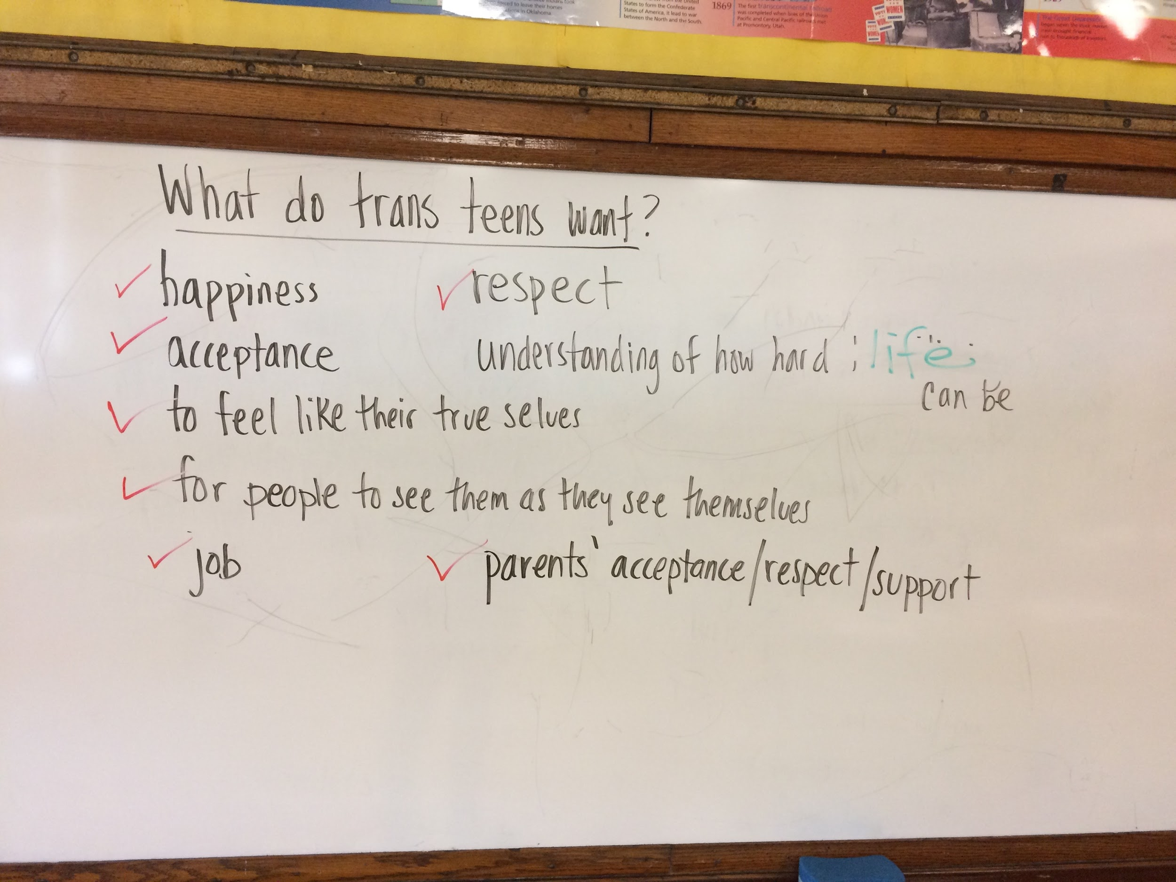
We started by providing some background information on safety for trans people, the difference between gender identity and sexuality, and the importance of using respectful terminology. After reading about a few young people in Texas fighting for acceptance, and watching the video with trans teens speaking to their future selves, we asked the class to share out what trans youth want. The image below shows their collective responses:
Students were quickly able to list eight things that trans teens want. The one that is sort of erased and written over in green originally said “understanding of how hard transitioning can be.” After we wrote the list, I asked students to identify statements on that list that they could relate to, that they wanted for themselves. That is represented by the red check marks. Students in the class could relate to all of the statements, except the one that was specifically about transitioning. I asked them, if I replace the word transitioning with “life,” can you related to wanting adults to understand how hard life can be? There was a resounding consensus of “yes.”
With the purpose of providing space for first-person narratives and helping students empathize with trans youth, we also read excerpts from Christina’s chapter of Beyond Magenta. In these pages, Christina describes her own process of coming out as trans,her relationships with her family and peers, challenges she faced, and hopes for the future. We asked students to write a reflection paragraph about how they could relate to Christina. I specifically said that it need not be about gender or sexual identity. Immediately, Delia called out, “I can’t relate to her at all.” Delia was one of a few students who showed resistance to this topic and seemed uncomfortable, stating that trans people are “weird.” I challenged her to consider the relationship that Christina had with her mother. “You can’t relate to having a secret you wanted to keep from your parents? Or you and a sibling trying to hide something from your parents?” She agreed that she could relate to those topics. The next day, we asked students to share out how they could connect to Christina. The results are in the image below:
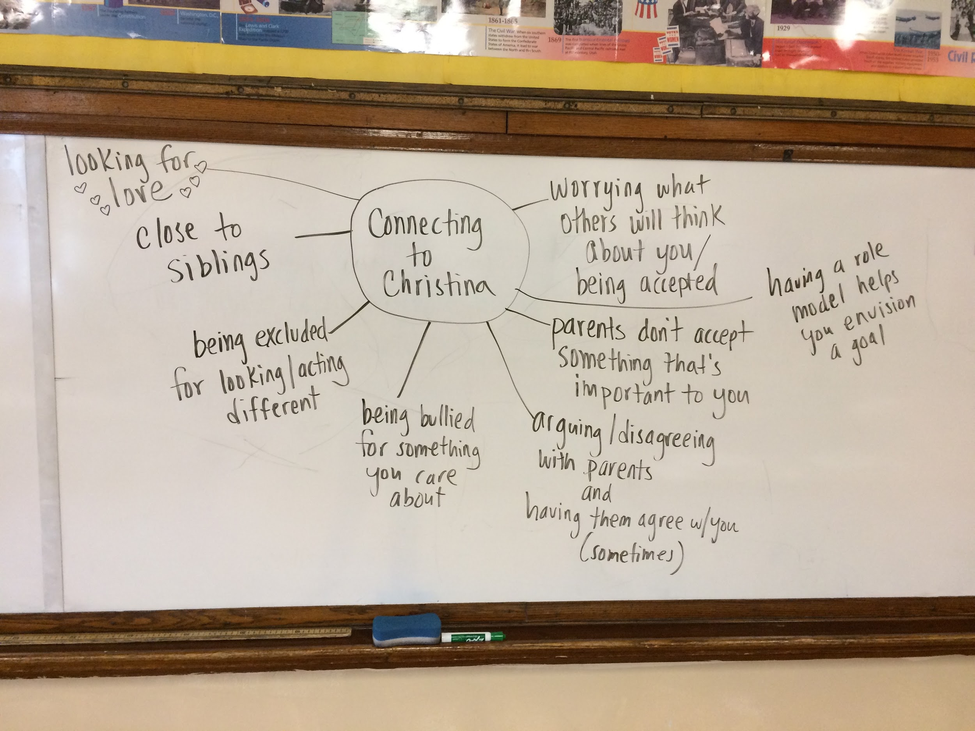
Students were able to connect in several deep ways to Christina’s story. To me, this was one of the most powerful class moments of the year. Together, as a class, we had engaged with a challenging topic - gender identity - and had come out with a sense of connection, shared experience, and understanding. I can’t predict how this experience will transfer outside of the classroom or into their futures, but I sincerely hope that it will stay with my students as they interact with people, and help them seek commonality instead of judging difference.
This topic provided several students with the opportunity to challenge others’ biased views and hurtful comments. Rose and Adrianne, on more than one occasion, publicly challenged their peers, without naming them, for saying that trans people are weird or that they don’t support trans rights. Adrianne in fact got very upset during one class discussion and I pulled her into the hall to tell me what was going on. She told me that she was frustrated with Andres, who sat next to her, for saying that he didn’t understand trans people and still thought they were weird even after the texts we had studied. She and I talked about the importance of continuing to engage with people who disagree or express ignorance, but also the importance of protecting herself and that she had the power to move away from him or stop engaging when it got to be too much. My co-teacher and I also talked to Andres privately to try to understand his perspective. It seemed that he was not open to having his mind changed, but neither did he intend to offend Adrianne or say anything hurtful. I am ending the year with Andres as a lingering challenge. A bright young man, who had high participation in class, but who may never have really opened himself up to being convinced that his previously-held ideas might be incomplete or inaccurate.
Discussing trans youth provided an additional opportunity for me, outside of the curriculum. Largely based on the professional development I gave to my peers on including students of diverse gender and sexual identities, the 5th grade teachers asked me to advise a group of students who were researching transgender rights for their 5th grade exhibition. I met with them and provided them with some additional links for information. This was a proud moment for me - that I am being recognized in the school as a person colleagues and students can go to for questions and support with LGBTQ issues.

2B. Impacts on student achievement
When selecting texts or changing unit plans, teachers consider the impact these choices will have on measures of student achievement, including standardized test scores and course grades. The topics we chose to discuss and the texts we analyzed were selected to promote student discourse and engage students in thinking about complex topics. In this section, I look at trends in student performance on a standardized test, followed by an analysis of their grades in reading class.

2B1. Standardized tests
In terms of academics, I need to teach engaging topics and increase student participation because it correlates directly with grades and test scores. Students in 8th grade must pass the NWEA test, scoring at or above the 24th percentile, to graduate. Scores at the 50th percentile are considered on grade level, while scores above the 70th percentile are considered college-ready. As shown in the graph below, students with low class participation (purple) have lower standardized test scores than students with medium (blue) and high (teal) participation groups. While the standardized test does not measure critical consciousness, empathy, or concern about societal problems, it does serve as a barrier for students in terms of promotion to the next grade, graduation from 8th grade, and attendance at the highschool of the student’s choice. In this way, giving students access to fiction and nonfiction texts that will engage their participation provides them with opportunities to improve their reading skills so that they may avail themselves of more options for the future.

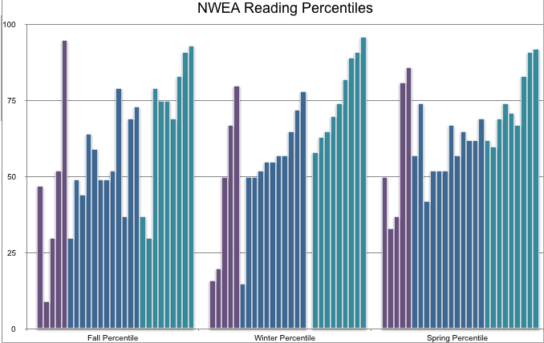

The three strands of the NWEA reading test are vocabulary, informational text, and literature. Through our work to vary the types of literature we read, including novels, short stories, poems, and songs, we were able to address the Common Core mandates of text complexity and intertextuality. Our focus on including high-level non-fiction, often selecting news sources geared towards adult readers, and providing supports such as reading the text aloud or analyzing texts in small groups, provided students with rich experiences of analyzing informational texts. Finally, we incorporated student-led vocabulary instruction throughout the school year, which enhanced engagement with the new terms.
The overall pattern from the fall to spring is growth, with 48% of students meeting or exceeded their growth target. 9 out of 10 of the students with the lowest percentile scores in the spring of 7th grade met their growth target. We ended the year with 23 out of 26 students at or above grade level (50th percentile), and the remaining three students who scored below the 50th percentile still met the graduation requirement of exceeding the 24th percentile. Of course this cannot all be attributed to a culturally-responsive curriculum, however, it certainly reinforces the idea that sacrificing “test prep” for authentic, social justice learning does not lead to poor test results. Quite the opposite - students who are interested in discussing theme and text evidence because they care about what they are reading are going to be learning more and be better able to apply those skills in a testing scenario.

2B2. Reading grades
Much like standardized test scores, class participation and grades are closely correlated. The graph below shows the grades of all students for all four quarters. For reference, A=90-100%, B=80-89%, C=70-79%, D=60-69% and F=59% and below. Almost all of the Fs and Ds in first and second quarter were earned by students in the low participation group (purple). All of the As in first quarter, and most of the As in second and third quarter, were earned by students in the high participation group (teal). Blue shows the students with medium participation, who tended to have mid-range grades. While class participation is one portion of the reading grade, it is not the majority. These grades reflect students’ engagement with other assignments, including interpretations of and reactions to pieces intended to raise critical consciousness. In other words, the students who are most successful at discussing these texts are also able to best demonstrate their learning in written form.
I find this data, along with the standardized test data discussed above, troubling but not surprising. The work we did this year to make the class more student-centered, more relevant, more engaging worked, but it worked best for students who are already successful at school. The students with typically high test scores and typically high grades like to talk in class. They understand what’s being studied and feel confident sharing their ideas. Aside from one student who tests well but rarely participates (Beatriz, discussed below), the remaining low participation students are precisely those for whom even a relevant curriculum is not enough. In the next section, I share some reflections on three students who did not transform as I had hoped they would.
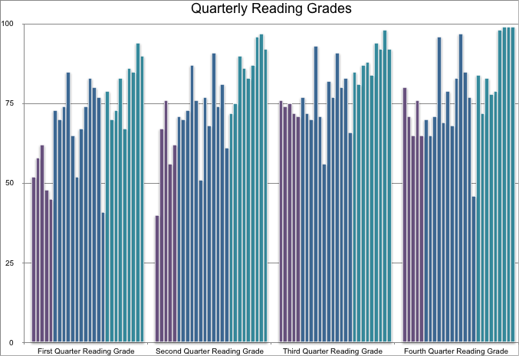

2C. Failing to reach students
In this section, I describe challenges in making the curriculum engaging and relevant to all students, then focus in on three specific students, Logan, Adam, and Beatriz, who I believe I failed to fully reach with my approach to culturally-relevant teaching.
As a teacher, I want to reach those students who are struggling. What I have noticed with this class, is that most students, regardless of their test scores, are able to produce work that is C or better quality. When students earn grades of D or F on report cards it is entirely due to missing work. Then I need to understand the psychology of a student who will sleep through class, or not turn in a notebook, or not complete an assignment in class because they are talking to their friends, or not do any homework assignments. These students are not completing work because it doesn’t matter to them, or matters less than the other concerns in their life. In order to make the work meaningful to them, I have to find out what they care about and try to connect the learning to their lives. For this reason, I asked students questions about their identities and home lives.

Student | Average Class Participation | 9-16 Response | 3-17 Response | Reading - Failing Grades
Genevive | High (100%) | “Living situation is currently a big mess a lot of back and forth.” | Separated/Divorced parents, Living far from school | D first quarter
Logan | Medium (60%) | “I live kinda far so I wake up early to get here which is why I’m always tired.” | Separated/Divorced parents, Living far from school | F first quarter, Ds second and third quarter
Adam | Medium (78%) | (left blank) | Siblings, Separated/Divorced parents, Social stress/Peers,  “Everything!” | Fs all three quarters
Beatriz | Low (43%) | “My brother is in a wheelchair which requires both of my parents to take him out of the house so if they are running late I might be as well.” | “Depression” | F first quarter, D second quarter
Sylvia | Low (50%) | “My responsibilities at home sometimes impact school because I have to watch my grandmother and this may cause me to be late or just not show up to school.” | “My home” | Fs first and second quarter
Joanna | Low (44%) | “Problems at home”  “Brother annoying me” | Sibling, Parents’ work, Social stress/Peers | F first quarter, D second quarter

Students who earned Ds or Fs throughout the year reported some challenges at home. Above are selected results from a questionnaire filled out on the first day of school and a follow-up survey given in March.
Students are dealing with home-based stress that can make it very challenging to complete assignments and feel motivated at school. While the table above only highlights some of the students who earned Ds or Fs, it does illustrate how home stress can align with poor school performance. All but two students (Logan and Adam) were able to bring up their reading grades by third quarter, and a third student (Beatriz) continued to have low class participation throughout the year, despite her high test scores. I feel that my work to engage students in culturally-relevant topics may not have benefitted these three students, I want to highlight interactions I had with them.

2C1. Logan
Logan has an emotional disability and a history of poor work completion, including falling asleep in class. So on the occasions that we were able to hold his interest, it was encouraging to have his participation. His best participation was in the whole class conversation about the prison strikes on December 12. He participated twice - once answering a question and another time stating an opinion and asking a question. This happened to also be an occasion on which he was removed from class for being disrespectful to my co-teacher. I escorted him to the hall, where we had the following exchange (as recorded in my teacher journal):

Me: So, look [showing diagram of class discussion], I was really proud of you for your contributions to our conversation today. It seemed like you had a lot to share.
Logan: Yeah.
Me: I wonder, though, how we can keep it from getting out of control.
Logan: Well the problem is Adrianne and Jackie. Adrianne’s too passionate and Jackie’s too attention-seeking.
Me: Did you say “attention-seeking?”
Logan: Yeah, like Adrianne will go off on something because she cares about it and then Jackie will see that she’s getting attention, so she’ll try to do it too. She wants the spotlight.
Me: I definitely see what you’re saying. How do we fix that?
Logan: You have to have a rule.
Me: Well right now people can call on whoever they want. Do you think it should be like you can’t call on someone if they’ve been one of the last three speakers?
Logan: Yeah, something like that.
Me: And we have certain people talk a lot, like Miranda and Cortez today, and then other people don’t talk at all.
Logan: And those are the people who probably have the most ideas.
Me: I know! I mean, at least for some of them I do, because they show it in their work or one-on-one, but then there’s other people and they don’t talk whole group, don’t show their thinking in their work, don’t talk one-on-one, and I have no idea what they’re thinking. I wish I could crack their heads open and look inside.
Logan: Yeah, well you have some people who are closed off and others who you can open like a briefcase.

Logan is a thoughtful, insightful young man. When he is interested, he has great ideas to contribute, and clearly can view the members of the class with a great deal of emotional intelligence. He also exhibits extremely challenging behaviors in the classroom, disrupting learning, refusing to engage with material, and mocking students and teachers. I do not feel that my approach, overall, has been successful with Logan, but there have at least been some moments when I have been able to see his intellectual and emotional strengths.

2C2. Adam
Another student who has struggled this year, Adam was identified as an English Language Learner when he transferred to our school. This is a mistake, as his father confirms that they speak English at home. Nevertheless, once a student enters the bilingual program, they must take an annual test (in English) to demonstrate proficiency. Adam’s scores have not been high enough to pass out of the program, which indicates that he may in fact have a learning difficulty, since a language difference can be ruled out based on his home language being English. On October 26, I pulled a small group of students, including Adam, because we had identified them as not participating greatly in class discussions up to that point (although over time Adam’s average participation was in the medium range). We sat together in the hall to discuss a news article about France’s ban on “burkinis” (full-coverage bathing suits). Here is an excerpt from my teacher journal on October 26, 2016:

Today we broke into four discussion groups. I took the kids who voices are almost never hear in class convo. in the hall [Sylvia, Adam, Beatriz, Delia, Jordan, Madeline and Joanna]. Right away, Adam said, “Why am I with the bad group? I always talk in class!” Instead of ignoring this comment, I addressed it by talking about...how I learned [about] internal processors...and I’m an external processor. I reflected that there’s more than one way to be smart, and that I thought some students in this group may need that extra space to gather their thoughts. It’s not bad or good, it’s just different. Then I said it kind of hurt my feelings that Adam would call it the “bad” group.” I said we might have some silence and that’s ok but that I want people to be able to share their thoughts.

My attempts to reset the tone of the group did not help to encourage Adam’s participation. Adam did not participate at all, even when prompted. The remaining students spoke between 2 (Sylvia) and 10 (Delia) times, with Madeline only speaking one sentence and only when prompted by me and her peers.

As time was running out, I directly asked Adam for his reaction. No response. Not when I offered for him to read from the reaction he wrote [in his notebook] yesterday. Not when his peers encouraged him to say something. We went back to the classroom.

Clearly, I had offended Adam by putting him in a group he perceived as being “bad,” because they don’t join class discussions. He felt misidentified and retaliated by refusing to speak.

As class dismissed, I asked Adam to come check in with me before leaving. He didn’t. I went in the hall and asked him again to come into the room. I said it seemed like I had offended him or hurt his feelings so I wanted to know what was wrong. He said “nothing.”

Although he wouldn’t speak to me then, I gave him the chance to follow up the next day. He again did not approach me, but when I asked him to come speak to me he did open up a bit. He told me he was mad and didn’t like being pulled in the small group. I pointed out that I had also observed his group discussion in class that day (a heterogeneous group) and saw him be interrupted, cut-off and talked over by two of his peers. It seems that he at least was able to recognize that my grouping him with the other students wasn’t malicious, and came from an intention to give him more space to talk without others interrupting him. Over the course of the year, though Adam engaged in class discussions 78% of the time, his work completion and quality remained poor. I wonder if perhaps I never chose a topic that interested Adam deeply enough, or was not able to push through the social stressors that kept distracting him from his work.

2C3. Beatriz
Another outlier in the class, Beatriz has extremely high test scores (80th-95th percentile in reading), low grades (Fs or Ds), and very low class participation. She is a student I’ve gotten to know over the years for her non-sequiturs, unexpected sense of humor, and her acting talent in the school play. Working with her this year, I also came to know her as someone suffering from mental illness. In February, after studying the song “I am a Rock,” by Simon and Garfunkel, I asked the students to complete a more creative activity - writing or drawing in response to the following prompts: Are you a rock? Are you an Island? If not, what landform are you? How do you know? What landform do you want to be? Why? What do others see you as? Is it true? Below is Beatriz’ response:
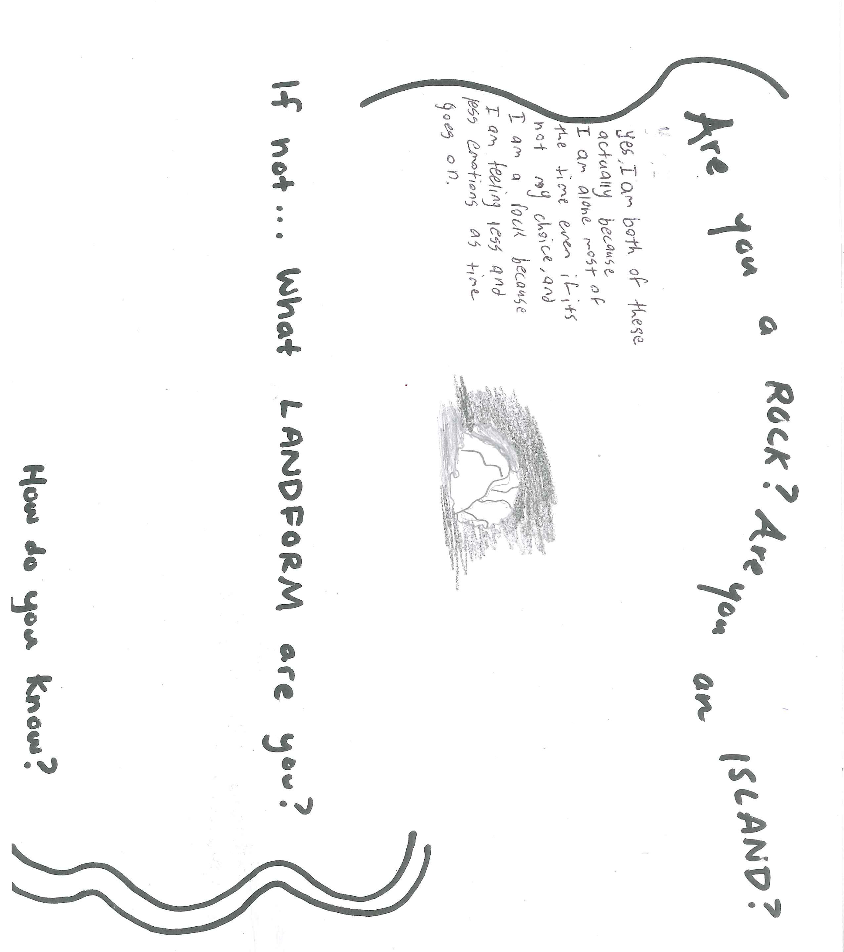
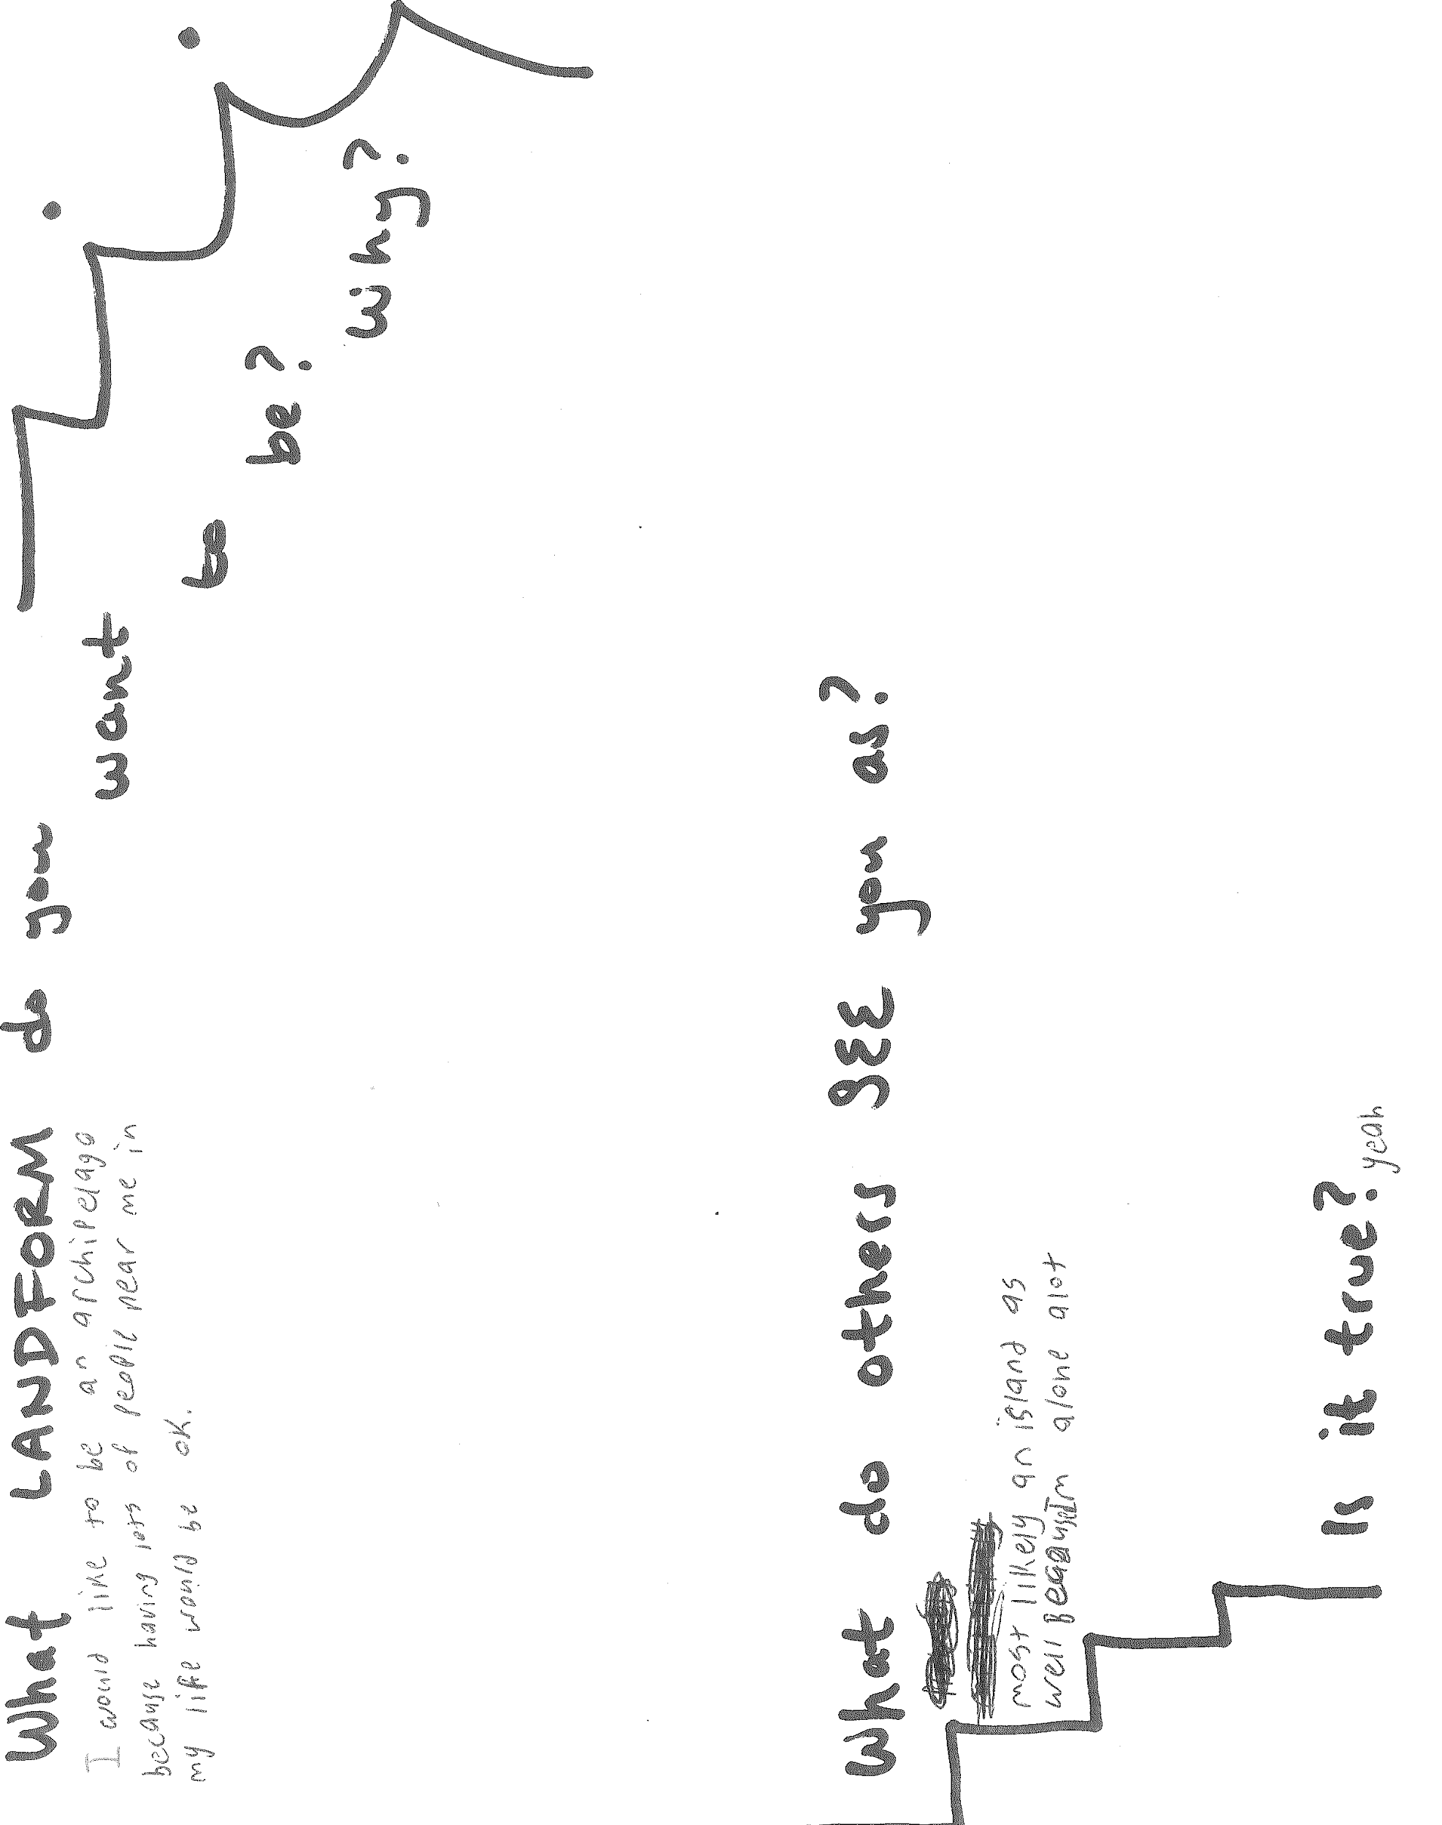
- Are you a rock? Are you an island?
  - “Yes I am both of these actually because I am alone most of the time even if it’s not my choice, and I am a rock because I am feeling less and less emotions as time goes on.”
- What landform do you want to be? Why?
  - “I would like to be an archipelago because having lots of people near me in my life would be ok.”
- What do others see you as?
  - “Most likely an island as well because I’m alone a lot.”
- Is it true?
  - “Yeah.”
Although she wasn’t the only student to self-identify as a rock or island, she was one of the few who didn’t say that she can sometimes be a rock/island but at other times is something else (a cloud, for example). Her desire to become an archipelago is poignant; she is okay with being an island but would like to have some other islands nearby. I wish that we had found a better point of connection for her, an area for her to feel confident or inspired enough to be noticed by her peers.
Later, in March, when given the opportunity to write a fiction story using class-generated vocabulary words, Beatriz “went into a lot of detail about her mental state and loneliness, very much expanding on what I saw in her rock/island reflection.” (Teacher Journal, March 3, 2017). She was speaking openly about it to her teachers through her written work. But she seemed to be using that openness to help drive her increased efforts at class engagement. At this point, she had shown herself to have the courage to choose the in-person conversation for “The Country of the Blind” story. She was the only student with low participation who opted to discuss in person instead of online, and she met expectations for that conversation. In the survey we gave in March, she identified depression as the home-based stress that affects her the most. This was not one of the listed options, but something she had to write in. Again, she was telling us something she needed us to know. By March, she had improved her reading grade from an F first quarter to a D second quarter, and ended third quarter with a C. This was entirely due to completing more work in class, so some portion of the curriculum must have connected with her better as the year went on. Perhaps her ability to name her mental health challenge, and feeling that it was noticed or acknowledged, provided her the space she needed to put forth more effort.
I wonder how Beatriz would have responded to a study of mental illness or mental health. Perhaps she and other students who struggle with stress and self-acceptance would have benefitted from delving into this topic. I think it’s one of the areas we should have tried to address and I want to consider how we might approach it with the same sensitivity and openness to different perspectives that we tried to use for the other groups we studied this year.
Through portraits of three students for whom I felt this work was less successful than it could have been, I have reflected on some of my choices in terms of a social-justice model for curriculum. I believe that I could have done more to help students explore their own personal and cultural identities, and that may have created a class environment in which some students may have found it more comfortable to share their thoughts. This could have helped students like Beatriz feel more confidence, or allow Adam to value his voice enough to insist that it is heard. For each of these students, more time emphasizing their personal value and importance to the class community may have improved self-esteem and buy-in to the work we were trying to do together.

Conclusion
My research this year is personally and professionally important to me, and speaks to what I need as a teacher to continue in this work. I must continually reconnect with what inspires me to teach and what I value about the profession. I have created the beginnings of a framework I can use moving forward to revise units to make them more culturally-relevant.

An Anti-Bias Framework for Revising Language Arts Units:
- Connect to students’ identities. Base this on the stories their teachers tell about them, how they self-identify at the beginning of the year, and the aspects of their identity they reveal throughout the year. Be purposeful in providing opportunities for them to show themselves and what they care about, particularly the problems in the world that most resonate with them.
- Connect to current events. Bring political controversy, protest, social movements, and global crises into the classroom.
- Study “others.” Address prejudices and stereotypes that students express by providing narratives that counter their single stories. Complicate monolithic views of groups that students lack exposure to. Teach about microagressions, challenge them, and support students who challenge their peers’ prejudiced statements.
- Employ a variety of text types. Include poetry, songs, video, photography, fiction and nonfiction. Students will understand themes more deeply when they study them across genres, and certain types of text will connect more with individual students.
- Use a variety of discussion formats. Varying whole group, small group, written and online discussion formats provides space for all student voices to be heard.
- Don’t reinvent everything. Connect thematically to the existing unit and consider the previous year’s text selections as a starting point. Replace elements of the unit to address the above criteria, selecting texts that help students access the universal themes that are the unit’s guiding concepts.
These six points represent a draft of my approach to co-teaching middle school Language Arts, but the success of this work is highly dependent on the relationship between myself and my co-teacher. However, being able to define my pedagogy is an important step to making it part of every collaborative teaching environment I am assigned to.

Limitations
In some ways, my data is limited by the fact that I was not able to shift all aspects of the curriculum to fit my project. That is the reality of working with a co-teacher and within an existing curricular structure. I do think that we covered several important issues and identity groups, but am disappointed we were not able to address mental health, among other topics, that I think would have connected to specific students.
As with all action research, my data is limited because it’s a small sample size and grounded within a very specific school and classroom context. One could not simply pick up these lessons and texts and place them in another time and place and find the same results. The work is highly contextual and must be situated in the identities, values, and prejudices of the students.

Action steps
On the classroom level, I need to continue to ensure that, along with my co-teachers, my curriculum adapts each year for the group of students in front of me and the important current events and social issues. In addition, whoever I am assigned to co-teach with, I need to work at the relationship so that we are both able to enact our view of culturally-responsive pedagogy. This requires reflection, communication, and flexibility, which of course are hallmarks of any successful relationship.
On a personal level, if I claim to be an anti-racist teacher and interested in actively anti-bias pedagogy, I need to continuously reflect on and refine how my teaching practices match my core beliefs. I must use controversial topics and social justice themes in order to stay connected to the reason I became a teacher in the first place.
Perhaps this approach to teaching could be shared through a study group or professional book club that challenges teachers to read and re-read the thinkers that inspired them as they became teachers, and to question whether or not they can still see that inspiration in their daily practice. For example, I could envision meeting with other teachers who have been inspired by Paulo Freire, Lisa Delpit, bell hooks, and others to re-read their seminal texts and reflect on how their pedagogies influence our choices in the classroom.
In light of the very personal and political nature of my project, I find it difficult to make broad recommendations for other practitioners. I would suggest that people critically inquire into their choices of texts, questioning the perspectives, biases, and mis-, under- or non-representation of specific groups in their curricula. Ultimately, though I believe culturally-responsive pedagogy should be a best practice that all educators strive towards, it depends on the willingness of the practitioner to be vulnerable, reflective, and courageous in climates that often ask (or demand) teachers to be compliant and safe.

Works cited

Coates, T. (2015). Between the world and me. New York: Spiegel & Grau.

Christensen, L. (2012). The danger of a single story. Rethinking Schools, 26(4).

Delpit, L. (1995). Other people’s children: cultural conflict in the classroom. New York:
The New Press.

Freire, P. (1970). Pedagogy of the oppressed. New York: The Continuum Publishing
Company.

Herrera, S. G., Holmes, M.A., & Kavimandan, S.K. (2012). Bringing theory to life:
Strategies that make culturally responsive pedagogy a reality in diverse
secondary classrooms. International Journal of Multicultural Education, 14(3), 1-19.

hooks, b. (1994). Teaching to transgress: Education as the practice of freedom. New
York: Routledge.

Kearns, S. (2012). Seeking research identity through the co-construction and
representation of young people’s narratives of identity. Educational Action Research, 20(1), 23-40.

Piazza, S.V., Rao, S., & Protacio, M. S. (2015). Converging recommendations for
culturally responsive literacy practices: Students with learning disabilities, English language learners, and socioculturally diverse learners. International Journal of Multicultural Education, 17(3), 1-20.

Picower, B. (2012). Using their words: Six elements of social justice curriculum design
for the elementary classroom. International Journal of Multicultural Education,
14(1), 1-17. 3

